Sacramento Regional Transit (SacRT) Street Harassment Outreach Summary

December 31, 2024

Table of Contents

1. Executive Summary 1
2. Transit Safety Questionnaire and Outreach 3
3. Summary of Results 4
   1. Questionnaire 4
   2. Stakeholder Interviews 18
   3. Operator Drop-in Session 19
   4. Additional Feedback 20
   5. Areas with Most Reported Harassment 21
4. Conclusions and Recommendations 23

Appendix A Outreach Materials and Schedule................................................... A-1

* 1. Printed Questionnaire (5 Languages)..............................................................................A-1
  2. Flyer ...............................................................................................................................A-12
  3. Outreach Schedule ........................................................................................................A-15

Appendix B Respondent Demographic Information ........................................... B-1

# Executive Summary

As part of a statewide initiative to improve public transit safety, Senate Bill 434 (SB 434) requires the top ten transit operators in the state conduct surveys to identify and address issues related to street harassment on public transit. To implement this requirement, transit operators are provided with a Rider Questionnaire, developed by the Mineta Transportation Institute at San Jose University to gather detailed information on the prevalence, locations, and characteristics of street harassment faced by public transit passengers.

In October 2024, SacRT used the tool developed by Mineta and launched a Rider Questionnaire to engage riders, specifically targeting underrepresented communities to ensure that experiences are not overlooked. The purpose of the outreach was to collect rider insights on transit safety, study the input and feedback received, and identify ways to enhance safety and create a more respectful ride across the transit system. The Rider Questionnaire was supplemented by additional outreach, including stakeholder interviews and operator drop-in sessions.

The outreach process was conducted from October 7 to November 10, 2024, and saw approximately 1,060 participants. The Rider Questionnaire was available online for the duration of the outreach process and 25 events were held to gather feedback. Participants included transit riders, members of the public, key stakeholders, and SacRT operators. Through the outreach process, SacRT was able to successfully obtain information and recommendations from participants about safety and harassment issues, which are summarized in this section and presented comprehensively throughout the full report.

**Key Findings**

* The majority of questionnaire respondents reported that they “almost always” or “always” felt safe using SacRT services.
* Many participants that noted feeling unsafe reported that this feeling was associated with disruptive behavior from other passengers, and/or with particular routes or stations/areas.
* Respondents cited the need for more security personnel at stations, buses, and on trains. There were also numerous requests for infrastructure investments, such as improved lighting, more cameras, and emergency call buttons.
* Respondents noted that long wait times and service disruptions also contribute to safety concerns. In particular, participants noted that service delays increased the amount of time riders may be waiting at stops and stations that may feel unsafe, such as low traffic areas during non- daylight hours.
* Respondents identified several accessibility challenges that impact rider experience, and at times, riders’ safety on the system, including difficulties with service animal accommodations, insufficient seating, and issues with boarding light rail trains via ramps, particularly with low-floor trains.
* Participants raised concerns about fare enforcement, particularly regarding students and unhoused individuals who ride for free and were reported by respondents to contribute to unsafe conditions at times.
* Operators reported experiencing harassment when operating light rail trains and buses.

A cross-tabulation analysis was conducted by demographic factors (age, disability, gender, income, LGBTQ+ identity, primary language, and race/ethnicity) to examine how responses to specific questions varied across these groups. The key trends that emerged from this analysis include:

* Many female respondents (40%), as with all other demographic categories, reported feeling ‘almost always’ safe when using SacRT services; however, female respondents were more likely to report feeling ‘sometimes’ or ‘almost never’ safe compared to respondents of other genders.
* Individuals who identify as non-binary or transgender reported higher instances of experiencing specific behaviors directed at them that made them feel unsafe compared to those who identify as male or female.

**Participant Recommendations**

* Participants recommended increasing visible security presence, particularly during high-traffic and late-night hours to enhance safety.
* Participants advocated for addressing disruptive passenger behavior through better enforcement of policies and introducing transit ambassadors and/or additional staff (e.g., security officers, fare enforcement officers) during peak hours.
* Participants suggested additional outreach programs to schools, and partnerships with schools, to educate students on riding public transit respectfully.
* Participants recommended upgrading infrastructure with better lighting, cameras, and emergency communication options to improve overall safety.
* Participants suggested increasing service frequency, especially during high-demand hours, such as peak commute hours, at times such as afternoons when students are traveling after school, and on weekends, when wait times may be longer.
* Participants advocated for enhancing communication about delays so that riders can shift travel plans to avoid potentially unsafe conditions for prolonged periods.
* Participants recommended prioritizing timely service in areas/times of perceived unsafe conditions.
* Participants suggested enhancing operational reliability to address concerns around missed or delayed buses, especially for vulnerable riders.
* Participants recommended improving ramp accessibility and train design for easier boarding, particularly for people with mobility challenges. In addition, participants noted a desire for more training for operators regarding service animals to help ensure consistent accommodations.
* Operators recommended improving their support system by increasing security presence, training, and providing better communication from management in handling incidents. In addition, operators suggested consistently implementing policies for enforcement and helping ensure supervisors are trained to support operators in managing difficult situations.

SacRT will use the passenger safety questionnaire results to inform next steps and develop future strategies that enhance the safety and security of riders. The data and feedback received identifies several recurring themes and specific areas of concern, such as lighting at transit stops, onboard security presence, or emergency communication systems. Recommendations provided by participants will continue to be carefully reviewed and prioritized based on feasibility, potential impacts, timeline of action and funding support. Updates on progress and planned initiatives will be communicated to passengers to demonstrate SacRT’s commitment to continuous improvement in safety.

# Transit Safety Questionnaire and Outreach

The outreach program included the following elements:

* Rider Questionnaire: administered online, in-person at SacRT stations and stops for buses and light rail services, and at community events
* Stakeholder Interviews: held with Community-Based Organization representatives and Mobility Advisory Council members
* Operator Drop-in Session: held at the SacRT Administrative Office (1400 29th Street) to gather feedback from bus operators
* Additional Informal Feedback

The Rider Questionnaire, developed by the Mineta Transportation Institute at San Jose State University, was mandated by California Senate Bill 1161 (2022) to gather detailed information on the prevalence, locations, and characteristics of street harassment faced by public transit passengers. In addition, California Senate Bill 434 (2023) requires the state’s 10 largest transit agencies, including SacRT, to use this tool to specifically engage riders from underrepresented communities, whose experiences may have been historically overlooked, and to collect their insights on transit safety.

The outreach effort for the questionnaire was conducted between October 7, 2024, and November 10, 2024. The questionnaire was shared via SacRT’s website, through press release and social media channels, and through distribution of flyers to stakeholder organizations and during outreach activities. The questionnaire was also translated into Chinese, Russian, Spanish, and Vietnamese to capture non- English speaking individuals and ensure equal opportunities for participation.

In addition to the online questionnaire, an outreach team gathered feedback from riders, operators, community-based organization representatives, and Mobility Advisory Council members via the following methods:

* **Intercept questionnaires**: The outreach team administered questionnaires to riders at stations and stops throughout the SacRT system.
* **Ride-alongs:** The outreach team rode on select bus lines and train routes administering the questionnaire to riders.
* **Pop-ups:** The outreach team administered questionnaires at community events, such as farmers markets and community fairs.
* **Operator drop-in session:** The outreach team conducted one in-person drop-in session with SacRT bus operators.
* **Stakeholder Interviews:** The outreach team conducted three virtual stakeholder sessions with representatives from stakeholder groups.

To incentivize participation, SacRT offered a $10 transit fare credit to individuals that completed a questionnaire, and a $50 credit to stakeholders that participated in interviews.

* Appendix A includes the schedule of outreach events and outreach materials.

 This section summarizes feedback riders shared informally during the outreach process, separate from the rider questionnaire. For example, passersby may have provided feedback to staff administering the questionnaire at transit stops but elected not to complete the Rider Questionnaire.

# Summary of Results

## Questionnaire

**SacRT Services — Frequency of Use**

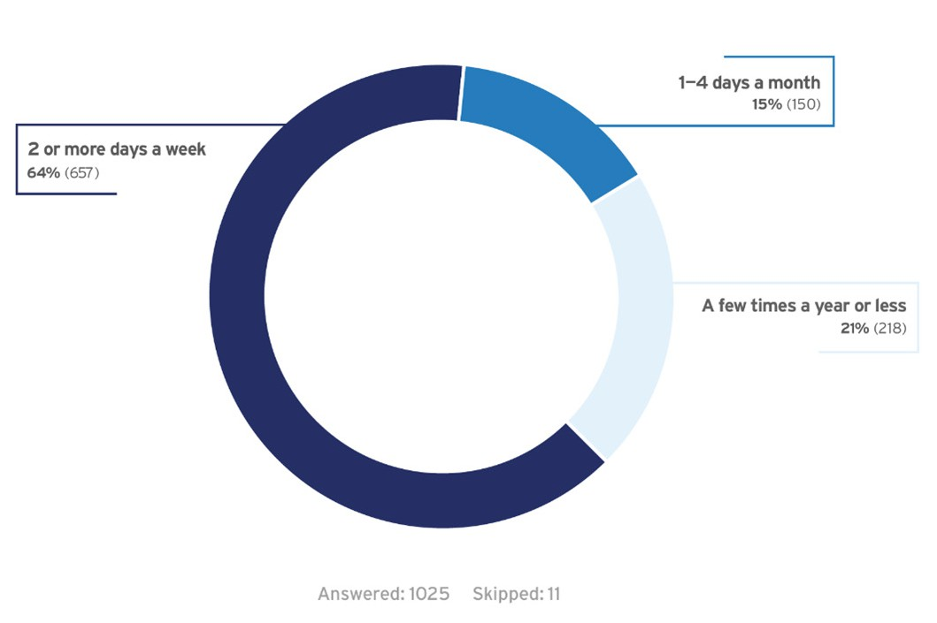

Most respondents are frequent users of SacRT services. Approximately 64% of respondents use SacRT services 2 or more days a week. Roughly 15% of respondents use SacRT services 1-4 days a month and approximately 21% of respondents use SacRT services a few times a year or less.

**Feeling Safe Using SacRT Services**

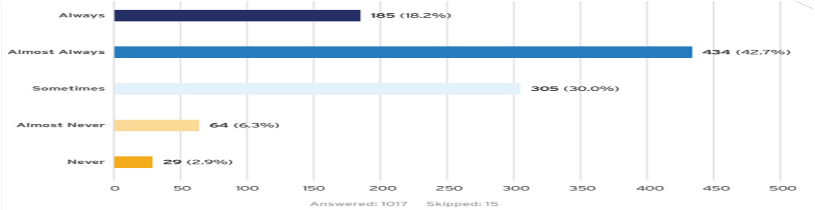

Approximately 61% of respondents indicated that they always or almost always felt safe using SacRT services while 30% of respondents indicated that they sometimes feel safe. Nearly 10% of respondents almost

never or never felt safe using SacRT services. Notably, many female respondents (40%), as with all other demographic categories, reported feeling ‘almost always’ safe when using SacRT services; however, female respondents were more likely to report feeling ‘sometimes’ or ‘almost never’ safe compared to respondents of other genders.

**Feeling Safe Using SacRT Services**

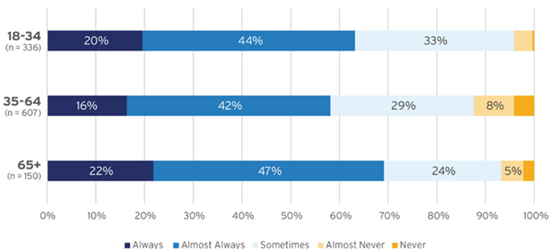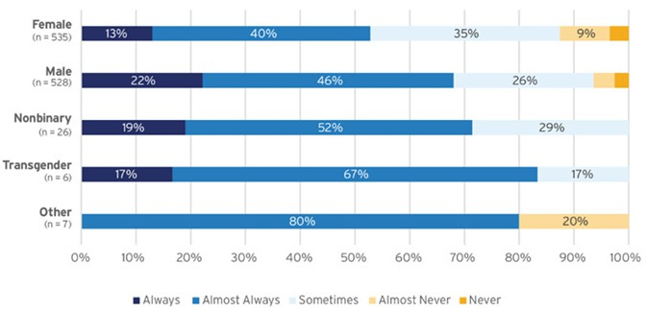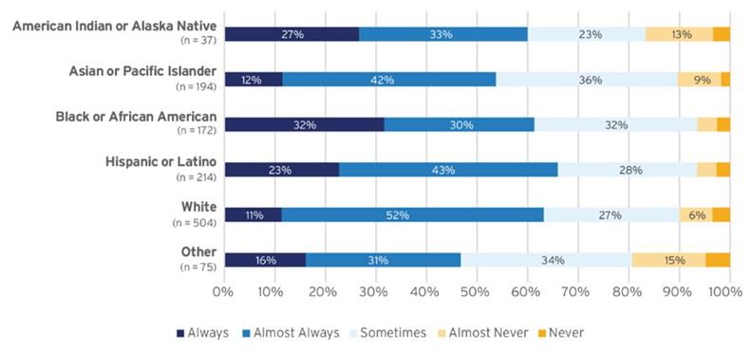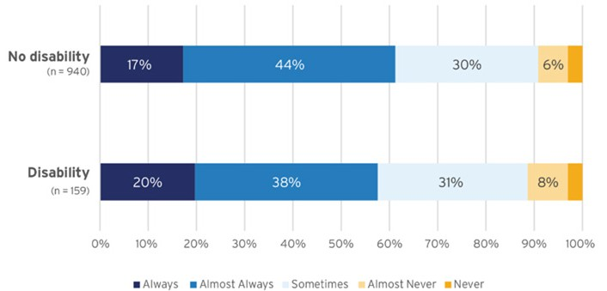

*The following charts present a cross-tabulation by demographic (age, gender, race/ethnicity, disability) to see how responses vary across these different population groups. Data labels were omitted in these graphs when a response’s frequency was less than five percent.*

Age Gender

Race/Ethnicity Disability

**Experience of Unsafe Behaviors**

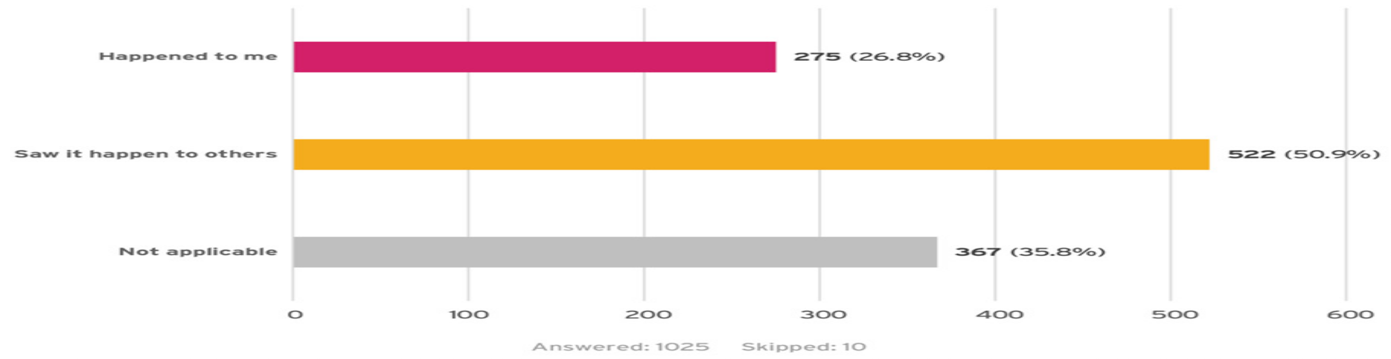

Over 77% of respondents experienced behaviors that made them feel unsafe or saw a behavior that they perceived made someone else feel unsafe. Approximately 36% of respondents selected “not appli-

cable,” indicating that they had not experienced behavior that made them feel unsafe or seen others

experience any of these behaviors.*,† Notably, individuals who identify as non-binary or transgender re- ported higher instances of experiencing specific behaviors directed at them that made them feel unsafe compared to those who identify as female, male, or other genders.

*\*If a respondent selected “not applicable” for this question, the questionnaire would skip the questions relating to the behavior and advance to*

*“Safety Precautions.”*

*† For questions with a “Check all that apply” option, percentages do not sum to 100%.*

**Experience of Unsafe Behaviors**

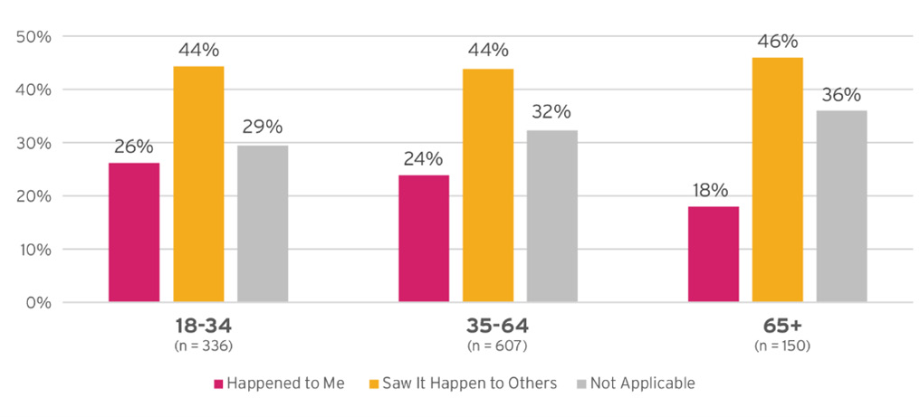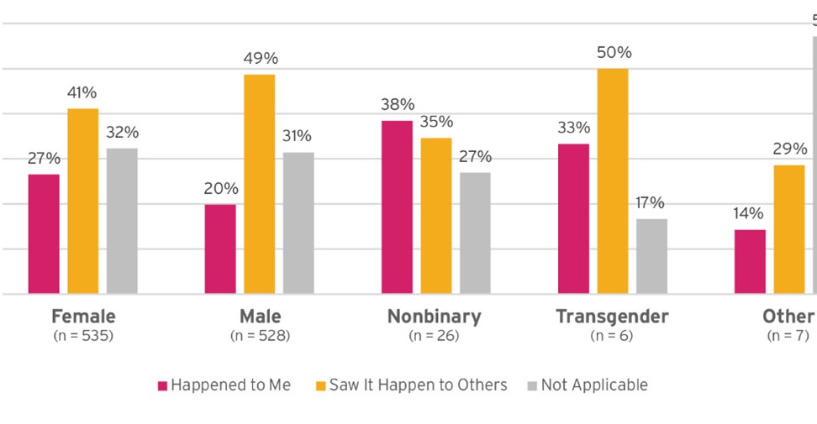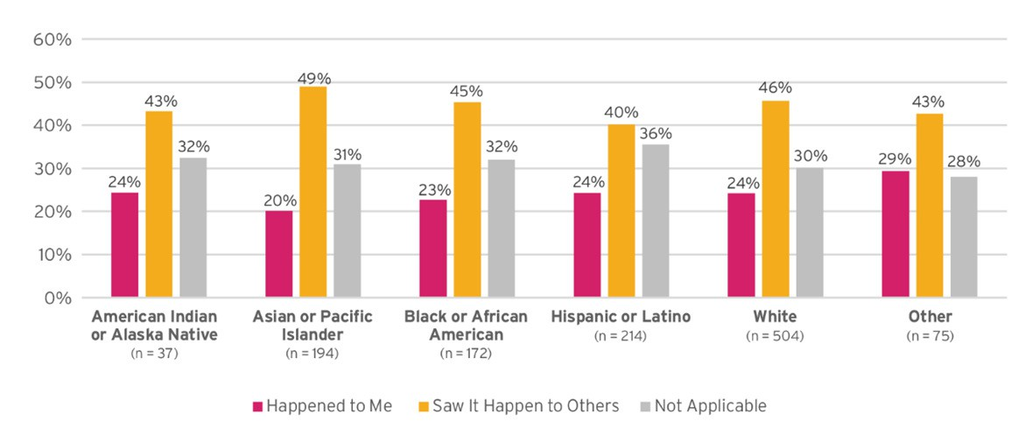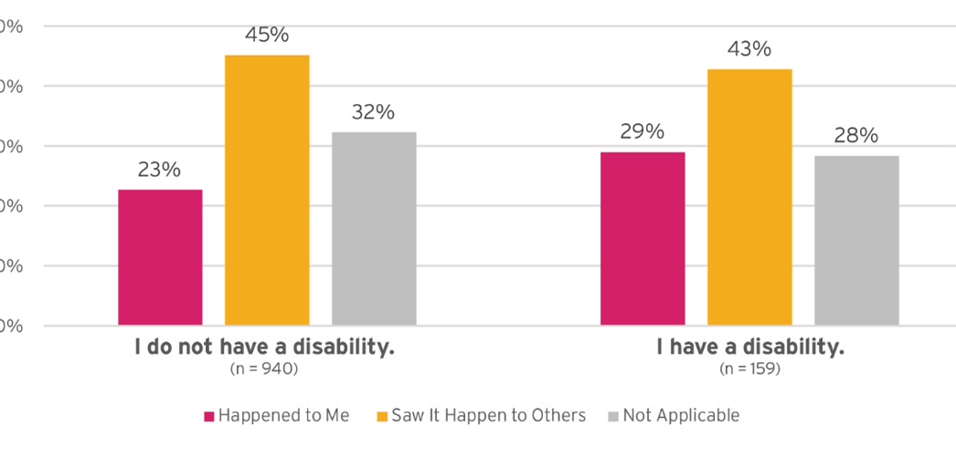

*The following charts present a cross-tabulation by demographic (age, gender, race/ethnicity, disability) to see how responses vary across these different population groups. Data labels were omitted in these graphs when a response’s frequency was less than five percent.*

Age Gender

Race/Ethnicity Disability

**Frequency of Experiencing These Behaviors**



Approximately 54% of respondents indicated that they sometimes experienced or saw behaviors that made them feel unsafe. Approximately 21% of respondents very frequently or frequently

experienced or saw behaviors that made them feel unsafe, while just over 23% of respondents almost never or never experienced or saw these behaviors.

**Frequency of Experiencing These Behaviors**

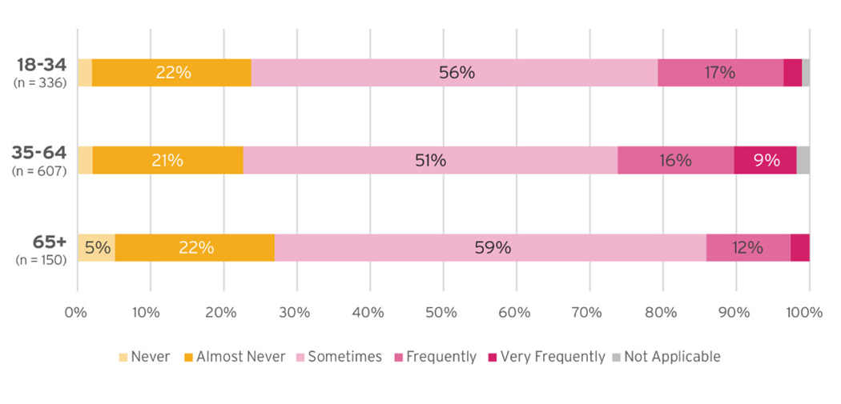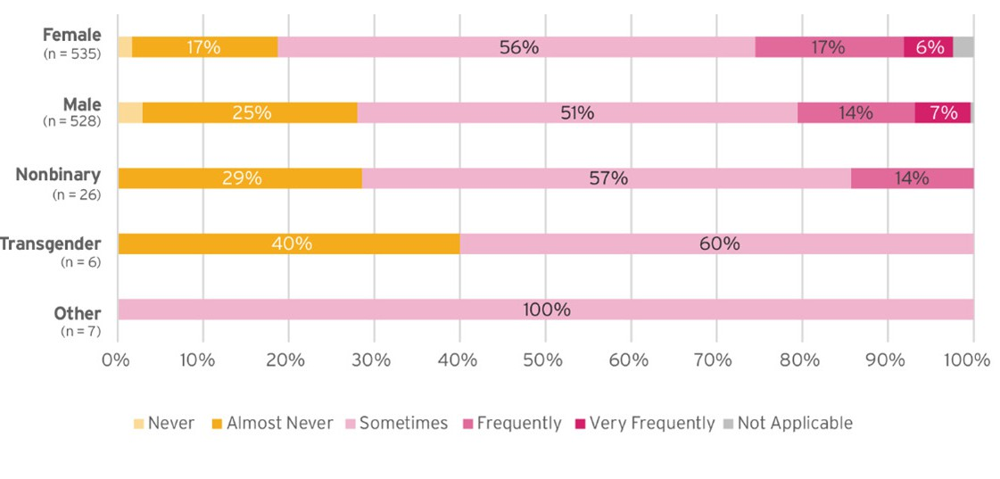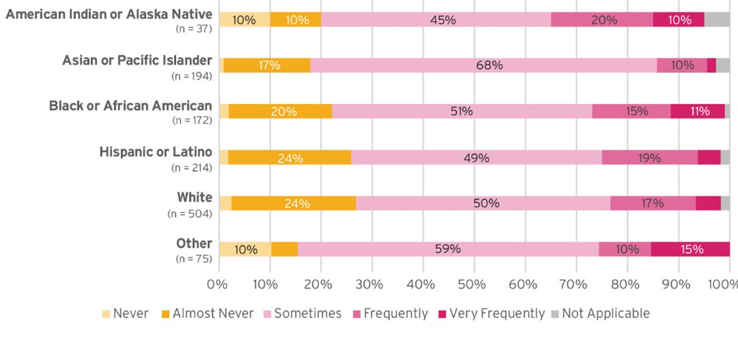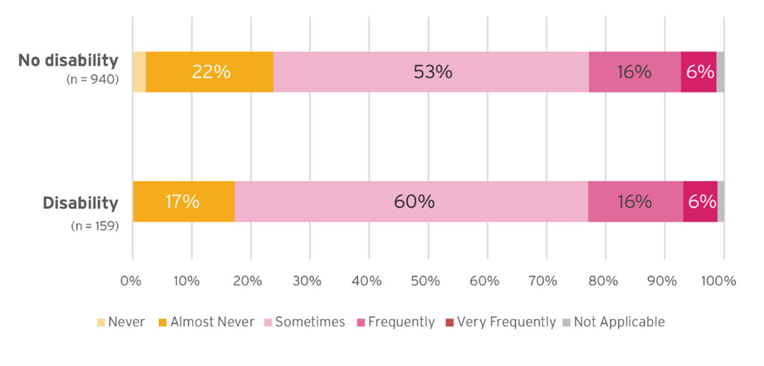

*The following charts present a cross-tabulation by demographic (age, gender, race/ethnicity, disability) to see how responses vary across these different population groups. Data labels were omitted in these graphs when a response’s frequency was less than five percent.*

Age Gender

Race/Ethnicity Disability

**Incident Locations**

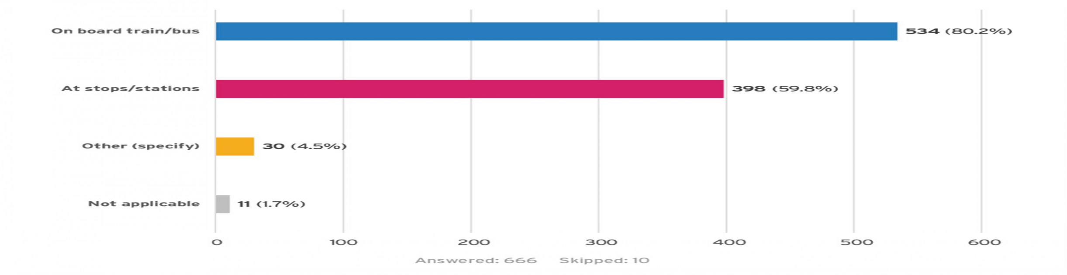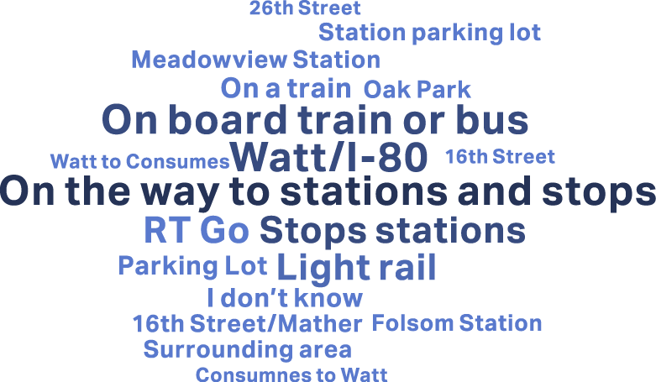

The majority of respondents, or 80%, indicated that incidents happened on board trains and buses. Nearly 60% of respondents experienced or saw incidents at stops and stations. Approximately 4% selected “other,” indicating these incidents happened elsewhere including at specific stations, stops, and routes throughout the SacRT system, parking lots, or on the street on the way to or from stations or stops.* The word cloud below highlights key responses provided in the the “other” response

category.

*For questions with a “Check all that apply” option, percentages do not sum to 100%.

**Incident Timing**

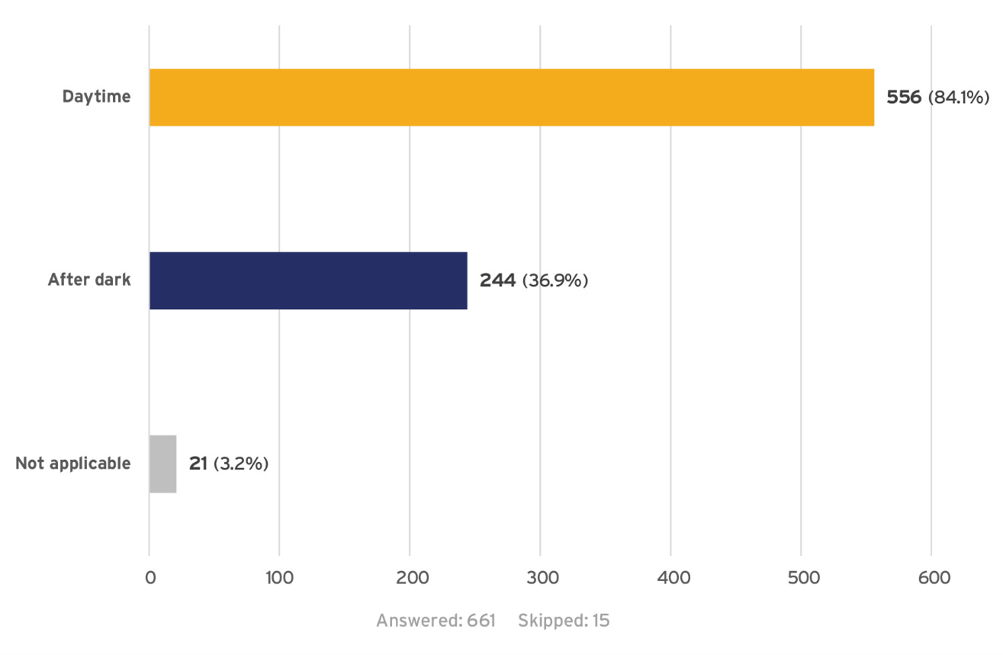

Approximately 84% of respondents indicated that incidents happened during the daytime while

nearly 40% indicated that incidents took place after dark.*,†

*In-person outreach/questionnaire administration was conducted almost exclusively during daylight hours.

†For questions with a “Check all that apply” option, percentages do not sum to 100%.

**Incident Reporting**

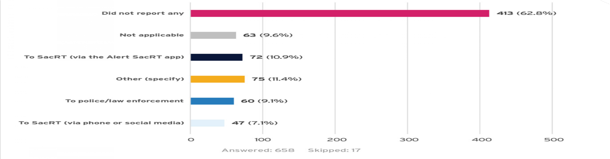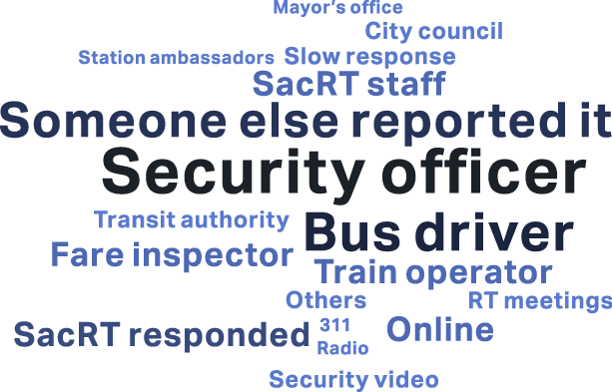

The majority of respondents, over 60%, did not report the incidents, while approximately 38% of re- spondents did report incidents or selected “other.” Respondents who selected the “other” option indicat-

ed that they reported incidents to security guards, transit officers, or to SacRT staff including bus driv-

ers, fare checkers, and train operators.*,† The word cloud below highlights key responses provided in the the “other” response category.

*If respondents indicated that they did not report any incidents, the questionnaire would advance to “Victim Targeting Reasons.”

†For questions with a “Check all that apply” option, percentages do not sum to 100%.

**Response to Incident Reporting**

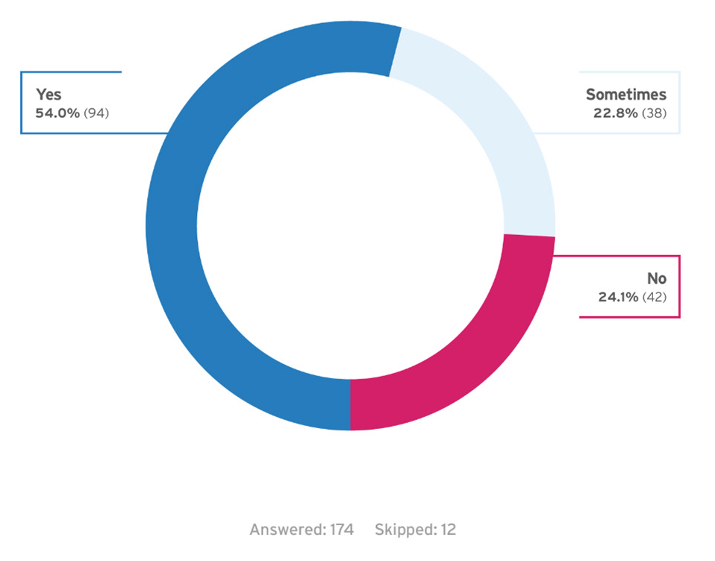

From the respondents who indicated they reported an incident, the majority of respondents indicated that they received an appropriate response. Approximately 22% sometimes received an appropriate response and 24% indicated they did not receive an appropriate response.

**Victim Targeting Reasons**

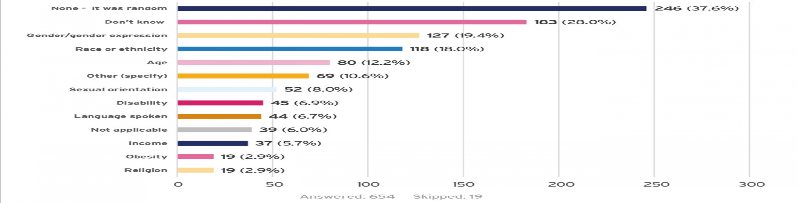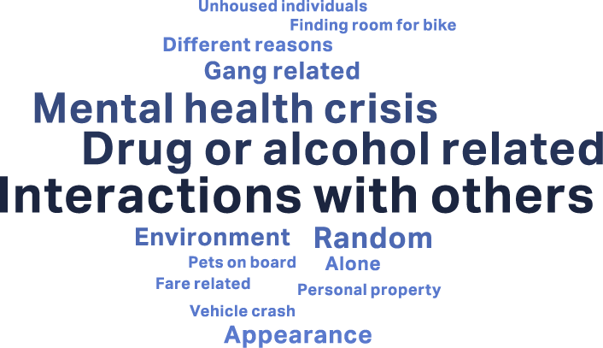

Nearly 38% of respondents indicated that they believed victims to be randomly targeted. In addition, respondents indicated a variety of potential reasons why a victim was perceived to be targeted. Gender/gender expression, race or ethnicity, and age were the most frequently cited.

Respondents also indicated a range of perceived reasons why someone may have been targeted aside from the questionnaire options, including: mental illness, gang-related disputes, drug-related conflicts, people under the influence of drugs or alcohol, and disagreements with other riders.* The word cloud below highlights key responses provided in the the “other” response category.

*For questions with a “Check all that apply” option, percentages do not sum to 100%.

**Safety Precautions**

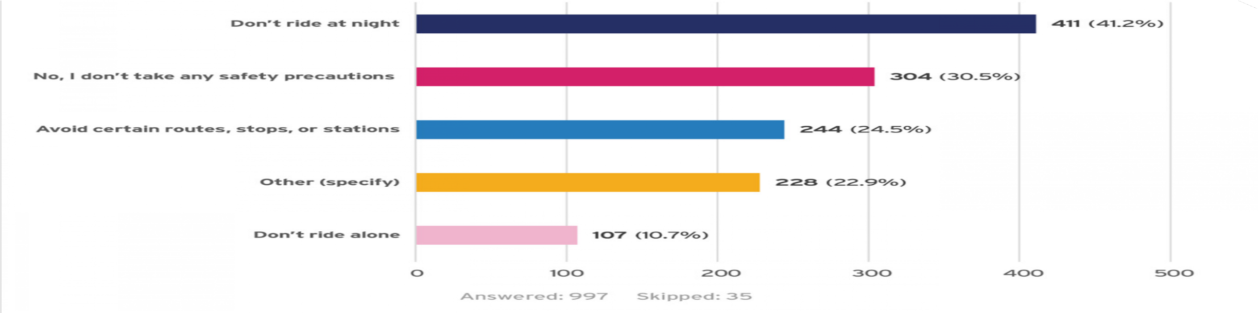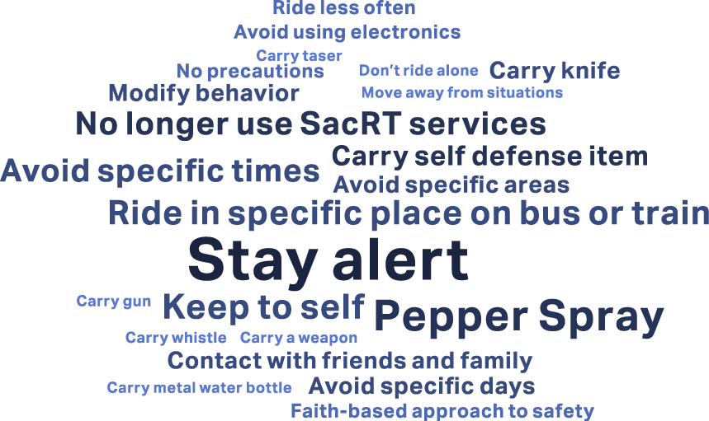

The majority of participants noted taking some safety precautions when using SacRT services. Just over 41% of respondents indicated that they do not use SacRT services at night.* Nearly 25% of respondents avoid certain routes, stops, or stations. Almost 23% of respondents indicated that they take other safety precautions including only riding on certain days of the week, being alert and

situationally aware, carrying pepper spray, mace, or other personal protection, and sitting in specific loca- tions on the train or bus. The word cloud below highlights key responses provided in the the

“other” response category. Some respondents also mentioned that they no longer use SacRT

services because of concerns about safety. A small percentage of respondents, approximately 10%, don’t ride alone. Approximately 30% of riders indicated that they do not take any safety precautions.†

*In-person outreach/questionnaire administration was conducted almost exclusively during daylight hours.

†For questions with a “Check all that apply” option, percentages do not sum to 100%.

**Other Comments and Changes SacRT Could Consider**

The questionnaire included two open-ended questions: one asking what changes SacRT could consider to help respondents feel safer on transit, at stops, and at stations, and another asking for any additional comments or experiences related to safety or harassment on SacRT services. Respondents provided a range of feedback and strategies addressing a variety of safety concerns, some of which were not directly related to street harassment. Key themes that emerged were similar between the two sets of responses. An overview of feedback received for both questions is provided below.

* **Accessibility:** Respondents noted a lack of accessible accommodations, including challenges with bringing service animals on board and lack of seating and ramps, as well as challenges boarding light rail trains via the ramps.
* **Communications:** Respondents expressed a mix of feedback related to the reliability of communications. Riders shared feedback about using the SacRT app, experiences with skipped announcements, lack of communication about safety-related incidents, miscommunications with operators or between riders and SacRT staff, and recommendations for diversifying communication methods for disabled riders and non-verbal riders. Respondents mentioned that they would like to see more ways to report incidents throughout the system, including help buttons and ways for drivers to communicate with law enforcement or other security personnel as well as indicated that it would be helpful to have alternative ways to report incidents and get help if riders are not able to access or use the SacRT app. Some respondents also expressed that they would like to learn more about the ways to report incidents or unsafe behavior and suggested public awareness campaigns or something similar.
* **Feedback on Fares:** Respondents indicated that they would like to see more fare checking throughout the system and additional fare enforcement officers. Respondents expressed concerns about those who ride free including students and unhoused individuals who were reported by respondents to be disruptive and engage in unsafe behavior or contribute to unsafe conditions at times.
* **Ridership and Rider Experience:** Some respondents mentioned that student riders were disruptive to both operators and other riders and could be unpredictable, contributing to unsafe conditions. Respondents also shared a variety of personal anecdotes including experiences with people undergoing mental health crises, violent interactions, drug-related concerns, seeing people with or using weapons, and general harassment. Additionally, many respondents mentioned concerns about and experiences with unhoused community members at stops, stations, and on board.
* **SacRT Staff:** Some riders expressed appreciation for bus and light rail operators and indicated that they were helpful, but others mentioned experiences with operators skipping stops, not waiting for riders, acting disrespectful towards disabled riders, and/or not accommodating service dogs or other accessibility needs.
* **Security and Infrastructure:** Many respondents provided feedback related to security at stations including requests for more security personnel (such as station ambassadors, SacRT staff, and/or police or law enforcement presence), especially in high-traffic areas and during evening and nighttime hours. Additionally, riders requested implementing infrastructure updates to make stations and stops feel safer, such as more lighting or fixing broken lighting, security cameras, and emergency buttons or call stations. Respondents also shared the need to be hypervigilant on board and at stops and stations due to experiences with harassment and safety.
* **Service Updates:** Respondents indicated that they would like to see an increase in frequency for both bus and light rail service, particularly on weekends, peak commute hours, and extending hours of operation. Some respondents indicated they were feeling unsafe during longer wait times, especially when buses did not arrive on time or missed stops. There were also requests to bring back particular bus routes that have been discontinued and extend routes.

Following the safety questionnaire questions respondents were provided with an optional section of demographic questions to capture the characteristics of questionnaire participants. See Appendix B for demographic information results.

## Stakeholder Interviews

Three stakeholder interviews were held on October 29th and 30th, 2024, as outlined in the table below. Invitations to participate in stakeholder interviews were sent to 13 stakeholder organizations.

Representatives from the SacRT Mobility Advisory Council (MAC), Asian Resources, Inc. (ARI), and the California Hispanic Resource Council attended at least one of the stakeholder interview sessions.

|  |  |  |  |  |
| --- | --- | --- | --- | --- |
| **Date** | **Time** | **Location** | **Participating Organizations** | **Number of Participants** |
| 10/29/2024 | 5:00PM – 6:30PM | Virtual via Zoom | SacRT Mobility Advisory Council (MAC) | 1 |
| 10/30/2024 | 10:00AM – 11:30AM | Virtual via Zoom | Asian Resources, Inc. (ARI) | 2 |
| 10/30/2024 | 1:00PM – 2:30PM | Virtual via Zoom | SacRT MAC  California Hispanic Resource Council | 2 |

The purpose of the stakeholder interviews was to provide a voluntary opportunity for stakeholders to share their perspectives on harassment on the SacRT system, and any associated ideas to address harassment.

The following questions were used as general guides for conversation:

* + - What have you observed, or heard from your constituents, regarding harassment on the SacRT system? This could include stations, stops, or routes.
    - Do you notice any patterns regarding harassment on buses or trains? With this question, we are looking to understand if there are patterns we should be trying to address, such as day of week, time of day, whether these incidents are being observed on light rail or buses, and in certain areas or routes. We can take notes on any specifics, such as stops, stations, or routes. We would also appreciate hearing if you have observed any other patterns in harassment.
    - When these harassment incidents happened, do you think there was a particular reason the victim was targeted? Is there anything else you would like to add regarding potential harassment targeting?
    - Do you have thoughts on how harassment might be impacting rider experience and/or travel choices? For example, do you think potential riders are deciding not to ride or avoiding certain times of day or days of week? Or avoiding certain modes, routes, or areas?
    - Keeping in mind everything we talked about, do you have suggestions for addressing harassment on the SacRT system? For example, are there ideas you have that would help keep SacRT safe?
    - Do you have any other thoughts on harassment on the SacRT system that you’d like to share?

Key themes that surfaced during the stakeholder interviews are provided below.

* + - Participants expressed general appreciation for SacRT operations.
    - Some stakeholders avoid riding in certain locations, and during non-daylight hours, due to harassment and safety concerns. Stakeholders suggested having additional security presence at night, and more lighting, to address these issues.
    - Stakeholders highlighted service disruptions, such as long wait times and cancellations, particularly with SacRT GO paratransit services, as contributing to harassment and safety concerns. They recommended more frequent communication about bus arrival times or delays and requested improved service reliability and frequency to avoid prolonged exposure to potentially unsafe conditions.
    - Participants expressed safety concerns about missing the last bus or situations in which the final bus on a route does not have enough ADA-accessible space available.
    - Participants noted a lack of public awareness about the online resources available for SacRT services and communications (e.g., mobile applications).
    - Participants indicated that women, the elderly, cognitively impaired individuals, people with disabilities, non-English speakers, and LGBTQ+ individuals are more vulnerable to harassment. Riders suggested creating women- and children-only compartments on trains and providing educational materials to promote respectful behavior, particularly to schools.
    - Participants reported disruptive or dangerous behavior from the public, including disrespectful language and inappropriate conduct from students, loud music, and dangerous behavior from unhoused individuals. They suggested adding transit ambassadors on buses to help address these issues.

## Operator Drop-in Session

The Operator Drop-in Session was held on Wednesday, October 23, 2024, from 10 am to 12 pm at the SacRT Administrative Office (1400 29th Street). The purpose of the Drop-in Session was to provide a voluntary opportunity for operators to relay their perspective and observations of harassment on the SacRT system. Twenty-two operators shared their perspectives during the Drop-in Session.

The following questions were used as general guides for conversation:

* + - Are there locations (e.g., stops, stations, or routes) where you notice rider harassment?
    - Do you notice any patterns regarding harassment on buses or trains?
    - Do you have thoughts on how harassment might be impacting rider experience and/or travel choices?
    - Do you have suggestions for addressing harassment on the SacRT system?
    - Do you have any other thoughts on harassment on the SacRT system that you’d like to share?

Key themes that surfaced during the discussions with operators are provided below.

**Safety and harassment:**

* + - Drivers consistently mentioned issues with harassment, both from riders and outside individuals. Specific concerns were identified related to violence, threats, and inappropriate behavior from passengers, especially minors, and harassment related to race.
    - Drivers discussed incidents of physical and verbal altercations, sexual harassment, and emotional distress caused by unruly riders. These drivers observed that there was insufficient support from transit management, police, and enforcement teams in addressing these incidents effectively.

**Desire for more support and resources:**

* + - Drivers expressed frustration with slow or ineffective responses from supervisors, transit police, or other authorities when incidents occur. Many feel they are "on their own" when it comes to handling safety or behavioral issues on the bus, especially during late hours or in less populated areas.
    - Drivers indicated a need for better communication and follow-up on incidents, as well as more proactive support, such as more police presence or quicker response times from supervisors.
    - Some drivers also described a difficult work environment influenced by supervisors who belittle and disrespect drivers, highlighting a need for supervisor training. Drivers suggested that having moderators listen to the radio to oversee supervisor behavior may help improve communication and support.

**Inconsistent enforcement of policies:**

* + - Drivers highlighted the lack of consistency in the enforcement of policies regarding fares, dogs, smoking, and the behavior of unruly riders. This includes inconsistencies in how fare evasion and disruptive behavior are handled, with some drivers enforcing rules strictly and facing challenges due to lenient responses from management, dispatch, or other drivers.

**Training and team communication:**

* + - Drivers recommended regular meetings among bus drivers to share information and help ensure that everyone is on the same page regarding new rules or operational changes and called for more coordination between drivers, dispatchers, and management.
    - Drivers also express a need for more comprehensive training, especially around handling difficult situations with riders and students.

**Concerns about student riders:**

* + - Several drivers stated that student riders can be a source of disruption, with complaints about children misbehaving, smoking, or refusing to follow rules and being disrespectful toward both operators and other passengers.
    - Some drivers proposed limiting student transportation, or shortening the long school bus routes, and increasing education on proper behavior while riding public transit. Other recommendations that were highlighted included having teachers, parents, or transit ambassadors ride along on buses (not just on light rail trains) during school runs to help ensure students behave appropriately. They also suggested that student fare policies be re-examined, such as eliminating free ridership or implementing a policy to remove free fares for students who misuse the service.
    - Drivers recommended that there be classes or training for drivers on how to manage difficult student riders without escalating the situation.
    - Drivers recommended that school districts or transit authorities collaborate to create clear guidelines and better oversight for managing student behavior.

**Environmental and operational issues:**

* + - Drivers noted infrastructure issues, such as inadequate lighting at stations, lack of garbage bins on buses, or issues with bus routes being delayed due to traffic or incidents. Drivers suggested better infrastructure, such as more lighting at stations, clearer signage, and more shelters at bus stops.
    - Drivers indicated a concern that certain bus routes, especially those with heavy ridership or late- night schedules, are particularly problematic in terms of maintaining schedules and dealing with disruptive behavior.
    - Several drivers mentioned that the presence of unhoused individuals near stations or bus stops creates safety and cleanliness concerns.

## Additional Feedback

This section summarizes feedback riders shared informally during the outreach process, separate from the rider questionnaire. This section also provides an overview of key topics raised that are tangentially related to safety, such as maintenance and infrastructure feedback. Key themes of this informal feedback are provided below.

* + - **General public behavior issues:** Riders noted disruptive and sometimes dangerous behavior from students and unhoused individuals, creating discomfort and affecting the decision to take public transit, particularly in public spaces near transit stops. Riders also noted increasing drug use on trains that is exacerbated by insufficient security presence.
    - **Inconsistent service and lack of security:** Riders noted that service disruptions, such as early bus departures and miscommunication between bus drivers, leave riders stranded and vulnerable to crime. Riders also noted inadequate security at various train stations and called for an easier way to reach law enforcement, such as emergency call buttons.
    - **Bus and station maintenance and infrastructure**: Respondents cited garbage on the ground or on the floors of stations, odors, and dirty seats on board at stops and stations as contributing factors to an overall feeling that the stations and stops weren’t cared for and creating an unpleasant rider experience, and/or discouraged riders from sitting down on transit or using transit at all. These concerns could affect public health and contribute to perceived health risks. Respondents had recommendations for improving station cleanliness, including the removal of

trash and repairing broken infrastructure. Riders also recommended infrastructure updates such as trash bins, water fountains, additional space for bikes on trains, and sheltered waiting areas for rain/weather protection to improve rider comfort.

* + - **Accessibility:** Respondents shared specific experiences related to boarding buses, seating on buses and light rail trains, miscommunications about service animals, and challenges with boarding the low-floor trains.

## Areas with Most Reported Harassment

Questionnaire respondents, stakeholders, and operators shared their experiences and perspectives regarding safety and harassment at stations, stops, and other locations throughout the SacRT system. Several locations were mentioned multiple times including the Watt/I-80 light rail and bus station, the 16th Street light rail station, downtown stations and stops, 7th and Richards Boulevard/Township 9, and Route

51. Feedback related to these locations included requests for additional security and lighting, concern over the perceived safety implications associated with the presence of unhoused individuals, experiences with people using drugs or drinking, and specific incidents of harassment that respondents experienced or heard about. Additional location-based feedback broadly echoed general feedback received related to security, cleanliness, and interactions with other riders (including students) or SacRT staff. There were also similar requests for infrastructure improvements including lighting and seating. The map below outlines areas, stations, and routes that were most frequently mentioned by respondents.

**Areas with Most Reported Harassment**

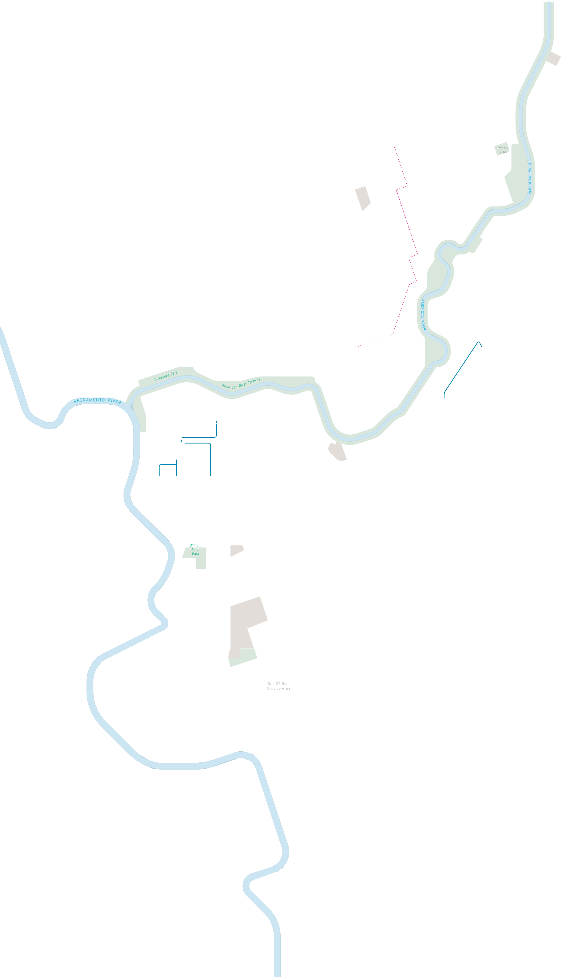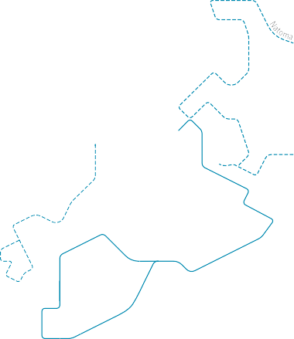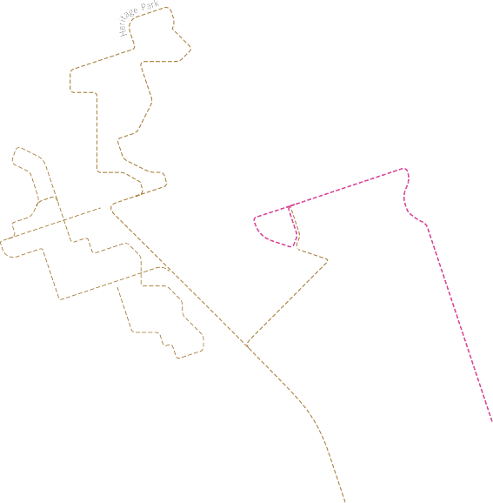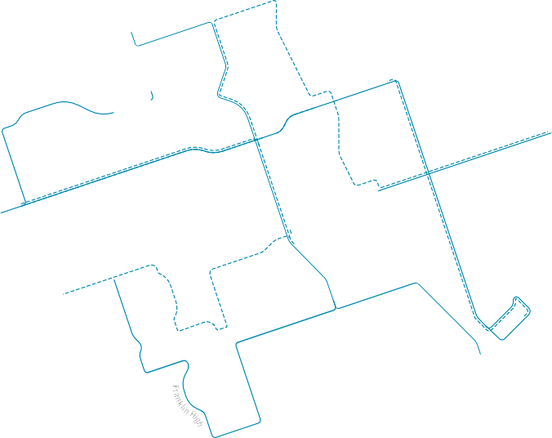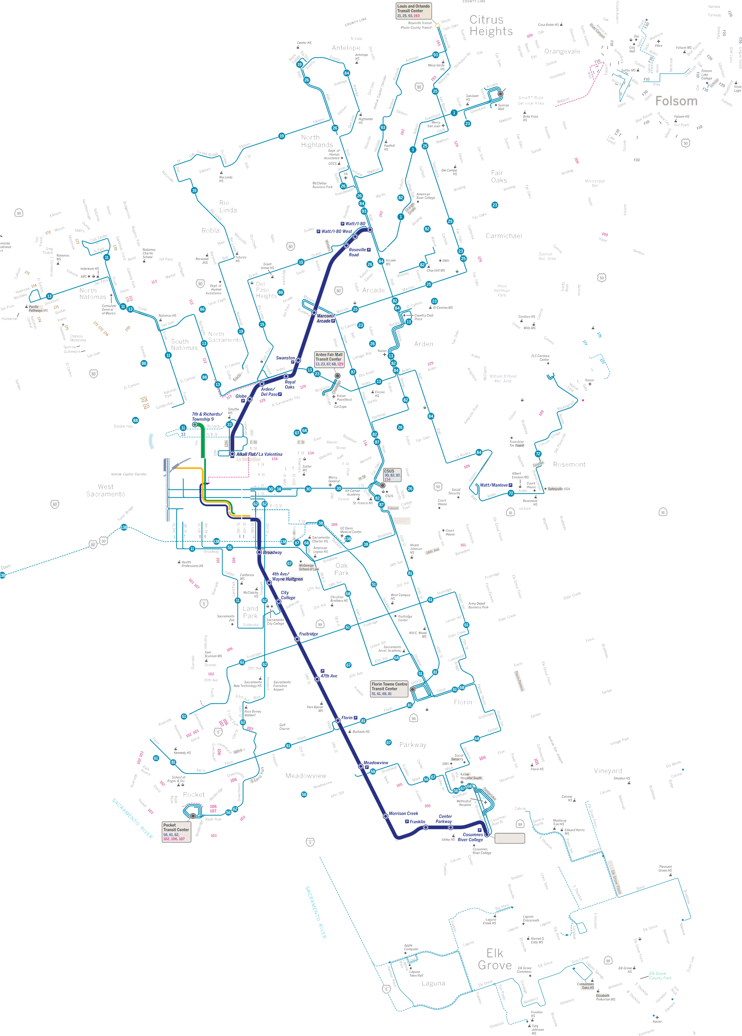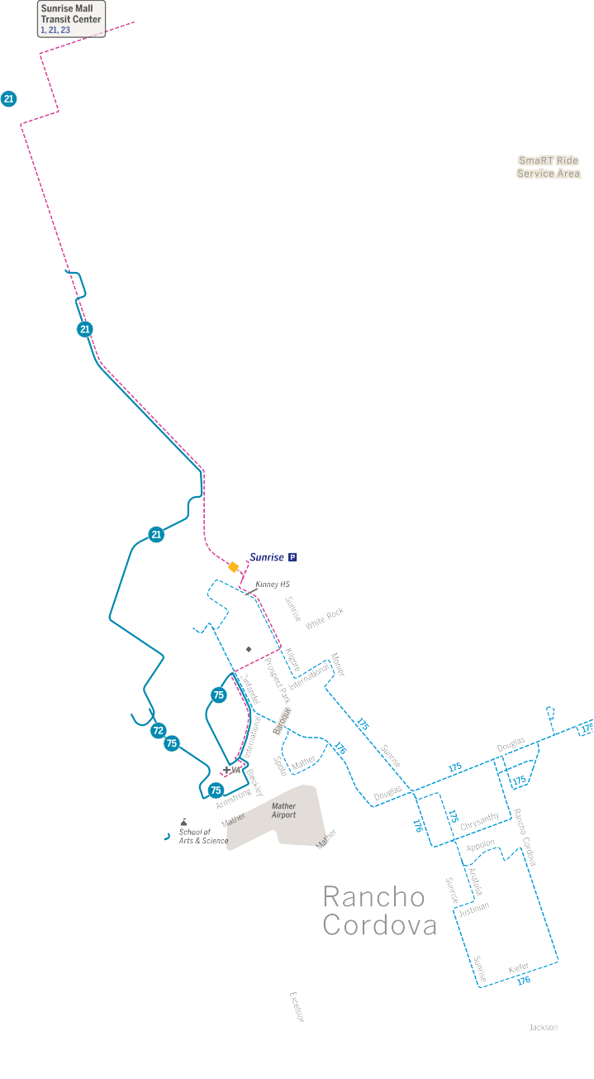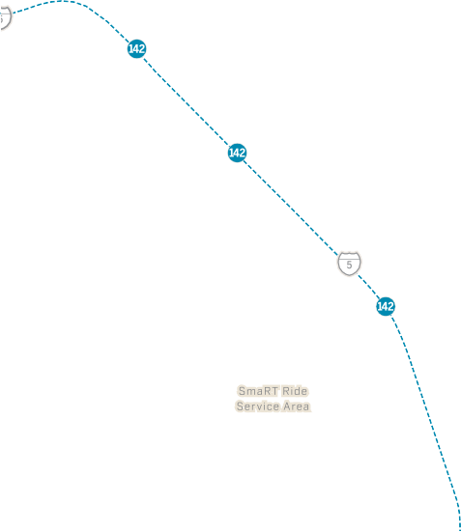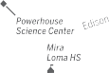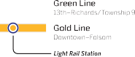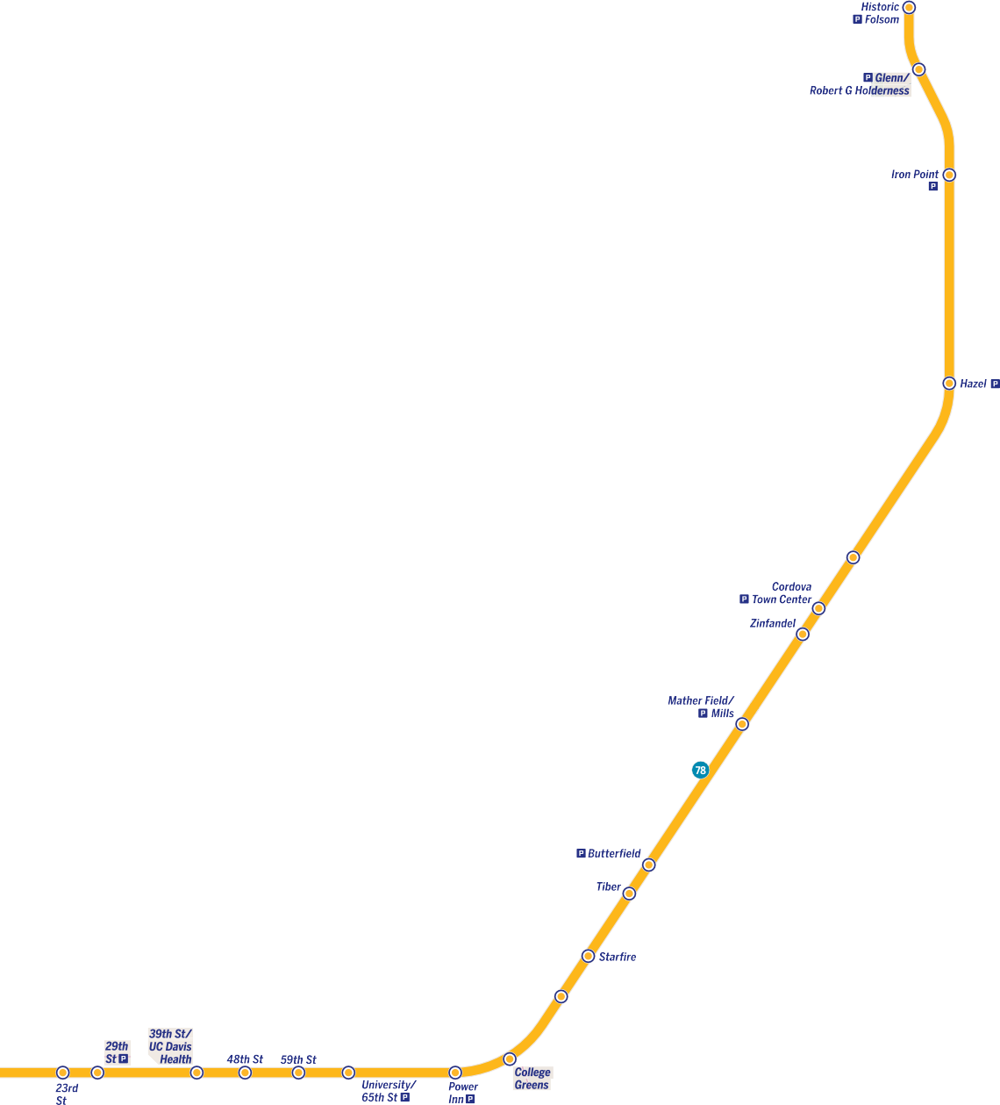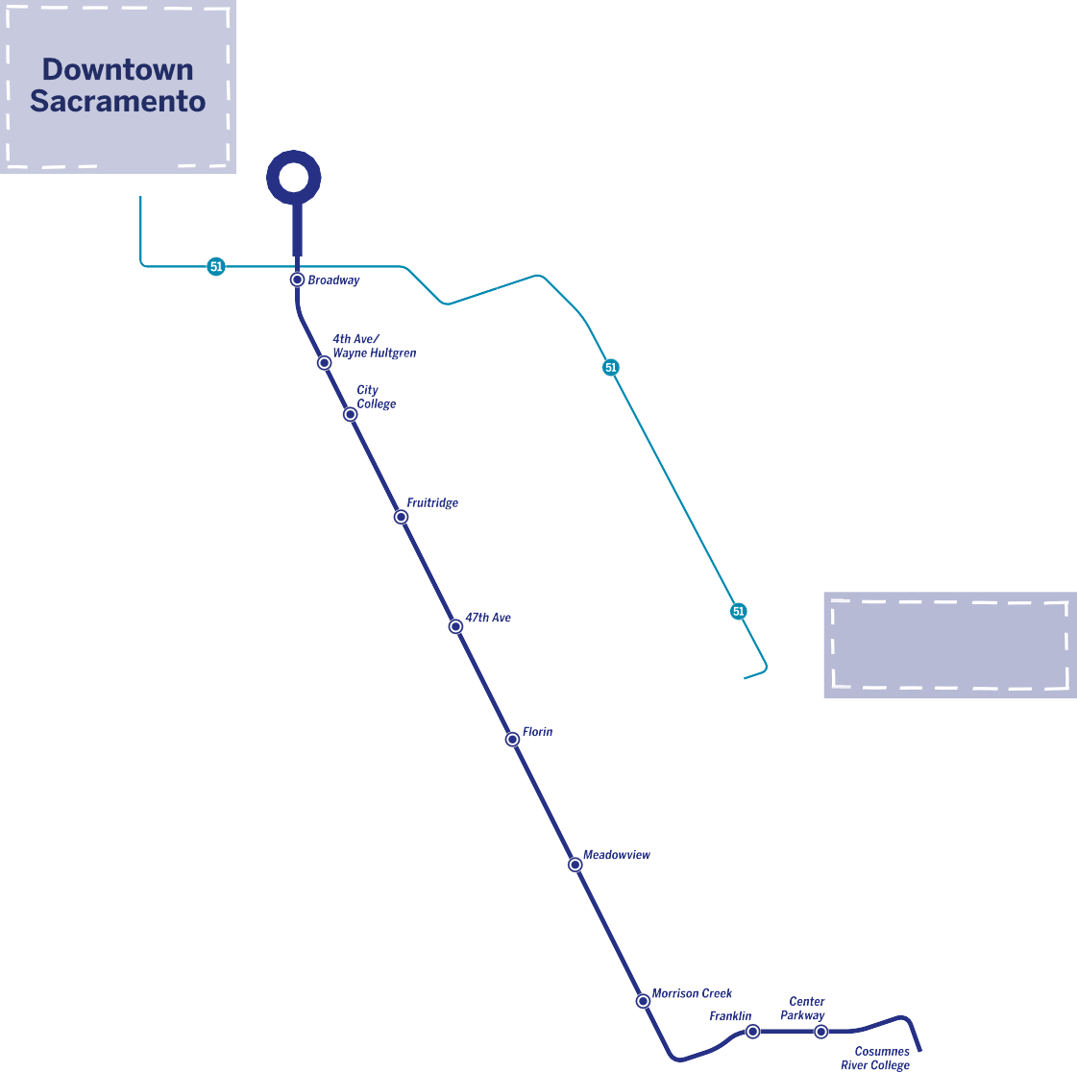

*Areas/Stations with most reported harrassment*

Bidwell

#### Bus & Light Rail System Map

**124**

***City Hall***

**124**

El9

#### 16th Street

#### Route 51

Effective **August 29, 2021**

EllO **Elk Grove bus**

ElO begin with E

**Folsom Stage Line**

begin with F

**Rancho CordoVan North Natomas Jibe**

SG, G7, G8, EllO,

S, EllG

**16th Street to CRC**

Ell4, Ell

El

El8 El9

# Conclusions and Recommendations

This section represents the conclusions that have been gleaned from the transit safety questionnaire results. In addition to the summary of findings, this section also includes recommendations suggested by questionnaire respondents about how to address safety and harassment issues on the system and an associated timeline of action. The timing to implement each recommendation is contingent upon multiple factors and is determined as either a ‘near-term’ or ‘long-term’ action. Actions that may be implemented within a reasonable amount of time and/or require minimal resources are considered ‘near-term.’ Actions that require additional planning, resources, and funding are considered ‘long-term.’

|  |  |  |
| --- | --- | --- |
| **Conclusions** | **Participant Recommendations** | **Timeline of Action** |
| Overall, many respondents reported that they ‘almost always’ or ‘always’ felt safe using SacRT services.  Stakeholders also shared an appreciation for SacRT services. Respondents reported that recent SacRT improvements have been helpful, such as the addition of transit ambassadors to light rail trains, and recommended similar improvements be made to SacRT buses.  Respondents reported mixed opinions on safety. Feeling unsafe was associated with disruptive behavior from other passengers, including students and unhoused individuals, as well as experiences associated with particular routes or stations and areas (e.g., Watt/I-80 light rail and bus station, Route 51) and times of day (e.g., non-daylight hours). For additional details related to areas with most reported harassment,  see Section 3.5 above. | Increase visible security presence, particularly during high-traffic and late- night hours. | Long-term |
| Address disruptive passenger behavior through better enforcement of policies and consider introducing transit ambassadors and/or additional staff (e.g., security officers, fare enforcement officers) during peak hours. | Long-term |
| Explore additional outreach programs to schools, and partnerships with schools, to educate students on riding public transit respectfully. | Near-term |
| Respondents cited the need for more security personnel at stations, buses, and on trains. There were also numerous requests for infrastructure investments, such as improved lighting, more cameras, and emergency call buttons. | Upgrade infrastructure with better lighting, cameras, and emergency communication options to improve overall safety. | Long-term |
| Respondents noted that long wait times and service disruptions also contribute to safety concerns.  Participants noted that service delays increased the amount of time riders may be waiting at stops and stations that may feel unsafe, such as low traffic areas during non-daylight hours. | Increase service frequency, especially during high-demand hours, such as peak commute hours, times, such as afternoons when students are traveling after school, and on weekends when  wait times may be longer. | Long-term |
| Improve communication about delays so that riders can shift travel plans to avoid potentially unsafe conditions for prolonged periods. | Near-term |
| Prioritize timely service in areas/times of perceived unsafe conditions. | Long-term |
| Increase operational reliability to address concerns around missed or delayed buses, especially for vulnerable riders. | Long-term |

|  |  |  |
| --- | --- | --- |
| **Conclusions** | **Participant Recommendations** | **Timeline of Action** |
| Respondents identified several accessibility challenges that impact rider experience, and at times, riders’ safety on the system, including difficulties with service animal accommodation, insufficient seating, and issues with boarding light rail trains via ramps, particularly with low- floor trains. | Improve ramp accessibility and train design for easier boarding, particularly for people with mobility challenges. | In-progress: light rail modernization  project |
| Provide training for operators regarding service animals to help ensure consistent accommodation. | Near-term |
| Concerns were raised about fare enforcement, particularly regarding students and unhoused individuals who ride for free and were reported by respondents to contribute to unsafe conditions at times. | Increase fare checking across the system to help ensure compliance. | Long-term |
| Reevaluate fare policies for students and unhoused individuals. | Near-term |

|  |  |  |
| --- | --- | --- |
| **Conclusions** | **Operator Recommendations** | **Timeline of Actions** |
| Operators reported experiencing harassment and a lack of support to safely address disruptive passengers and resolve safety incidents, with associated concerns about inconsistent policy enforcement and mixed responses from transit management. | Improve support for operators by increasing security presence, training, and providing better communication from management in handling incidents. | Near-term and long-term |
| Consistently implement policies for enforcement and help ensure supervisors are trained to support operators in managing difficult situations. | Near-term |

**Appendix A Outreach Materials and Schedule**

* 1. **Printed Questionnaire (5 Languages)**

This page is intentionally left blank.

**Sacramento Regional Transit Safety Survey**

**Complete this survey and**

**get a $10 credit on your Connect Card!**

Sacramento Regional Transit, or SacRT, is seeking to better understand how to keep bus and light rail train rides safe and respectful. The following questions are sensitive, but will help keep SacRT services and stations safe. Your response is important even if you choose to skip some questions.

The survey is for adults (18 years or older). All responses will be kept confidential.

1. How often do you typically use SacRT services, such as bus and/or light rail?

 2 or more days a week  1-4 days a month

 A few times a year or less

***The following questions ask about your experiences using SacRT services over the past year or so. Think about all parts of a transit trip, both onboard and while waiting at stations or stops.***

1. How often do you feel safe using SacRT services?
2. When did these incidents happen? (Check all that apply)

 Daytime  After dark

 Not applicable

1. When these incidents happened, did you report any of them? (Check all that apply)

 Did not report any

 To SacRT (via phone or social media)  To SacRT (via the Alert SacRT app)  To police/law enforcement

 Other (specify):  Not applicable

Always

Almost Always

Sometimes

Almost Never

Never

**7a.** Did you receive an appropriate response?

Yes

1. Have you experienced behaviors that make

you feel unsafe, or seen others experience this behavior, while using SacRT services in the past year? Examples of such behavior include hostile comments, sexual comments, following or stalking, unwanted touching, personal property damaged or stolen,

and sexual assault, among others.

 Happened to me

 Saw it happen to others  Not applicable

1. How often did you experience or see any of these behaviors when using SacRT services in the past year?

     

 Sometimes  No

 Not applicable

1. When these incidents happened,

do you think the victim was targeted because of…? (Check all that apply)

 Race or ethnicity  Religion

 Language spoken  Income

 Gender/gender expression  Sexual orientation

Age

Very Frequently

Frequently Sometimes

Almost Never

Never

Not Applicable

Disability

1. Where did these incidents happen? (Check all that apply)

 At stops/stations  On board train/bus

 Other (specify):

 Not applicable

 Obesity

 None – it was random  Don’t know

 Other (specify)  Not applicable

1. Do you currently take any safety precautions when using SacRT services to avoid

being harassed? (Check all that apply)

 Don’t ride at night

 Avoid certain routes, stops, or stations  Don’t ride alone

 Other (specify):

 No – I don’t take any safety precautions when using SacRT services

1. What changes could SacRT consider to help you feel safer on transit and/or at stops/stations?
2. Do you have any disabilities that affect

your experience using SacRT services?

 Yes  No

1. Gender (Check all that apply)

 Female  Male

 Nonbinary  Transgender

 Other (specify):

1. Do you identify as LGBTQIA+?

 Yes No

***ABOUT YOU***

*These questions are included to be sure we survey a mix of riders.*

1. Age

 18 – 34

 35 – 64

 65 and older

1. Home ZIP code

 Check here if unhoused

1. What is your primary language?

 English

 Other (specify):

1. Annual household income

 Under $25,000

 $25,000 – $49,999  $50,000 – $99,999  $100,000+

1. What would you say is your religion?

 None

1. Other comments or experiences related to safety/harassment on SacRT services:
2. Race or ethnic identification

(Check all that apply)

 American Indian or Alaska Native

 Asian or Paciﬁc Islander  Black or African American  Hispanic/Latino

 White

 Other (specify):

1. To receive a $10 credit on your Connect Card for completing this survey, please provide the email address that your account is linked to.

NOTE: Your email MUST be associated with a Connect Card account to receive the $10 credit.

***Thank you for completing the survey!***

**公共交通安全調查**

**完成此調查並在您的**

**Connect Card**

**上獲得 10**

**美元的充值金！**

沙加緬度地區運輸局 (Sacramento Regional Transit, SacRT) 正在尋求更好地了解乘客在乘坐公共交通時是否感受到安全。以下問題比較敏感，但可以幫助 SacRT 提高安全度。 即使您選擇跳過部分問題，您的回答依舊非常重要。

本次民調面向成年人（十八周歲及以上）。你的回答將會受到保密。

1. 您通常使用 SacRT 服務 ( 例如公車和 / 或輕軌 )的頻率是 ?

 每週兩日或更多  每月一日至四日  一年幾次或更少

以下問題關於您在過去一年左右使用 SacRT 服務的體驗。請回顧您使用公共交通時的全部過程，包括乘車與在車站等車。

1. 通常您使用 SacRT 服務時感覺安全嗎 ?
2. 這些行為發生在何時 ? ( 可多選 )

 白天

 天黑以後  不適用

1. 當上述事件發生時，您是否報告 ? ( 可多選 )

 無

 向 SacRT 報告 ( 透過電話或社交媒體報告 )  向 SacRT 報告 ( 透過 Alert SacRT 應用程式 )  向警察、執法機構報告

 其他 ( 請註明 )：  不適用

總是 幾乎總是 有時

幾乎從不 從不

**7a.** 您是否收到了合理的回覆 ?

有

1. 在過去一年使用 SacRT 服務時，是否經歷讓你感到不安全的行為，或看到他人經歷這類行為 ? 這類行為的例子包括惡意評論、色情評論、跟蹤或尾隨、不恰當觸碰、個人財產損壞或被盜，以及性侵犯等。

 本人經歷

 目睹他人經歷  不適用

1. 在過去一年，您在使用 SacRT 服務時經歷或看到上述行為的頻率有多少 ?

     

 有時  無

 不適用

1. 當上述事件發生時，您認為由於下列哪些因素導致受害人被針對 ? ( 可多選 )

 種族或民族  宗教信仰  使用的語言  經濟收入

 受害人的性別 / 性別表達  受害人的性取向

非常頻繁 頻繁

有時 幾乎從不 從不

不適用

年齡

 身心障礙

1. 這些行為發生在何處 ? ( 可多選 )

 在車站、停靠站  在車輛裡面

 別處 ( 請寫明 ):

 不適用

 肥胖

 無原因，隨機發生  不知道

 其他 ( 請說明 ):

不適用

1. 當您使用 SacRT 服務時，是否會採取以下安全預防措施 ? ( 可多選 )

 避免夜間乘坐

 避免某些特定的運行線路、停靠站、車站  避免獨自一人乘坐

 其他（請說明）：

 無，未在使用 SacRT 服務時採取任何安全預防措施

1. SacRT 可以考慮作出哪些變更，來幫助您在使用公共交通和 / 或在車站 / 停靠站時感到更安全 ?

關於您

*為了確保本次民調能夠廣泛傾聽社會的聲音，請回答下*

*列問題。*

1. 您的年齡

 18 – 34 歲

 35 – 64 歲

 65 歲及以上

1. 住址郵政編碼

 如無住址，請在此勾選

1. 您的主要語言是什麼？

 英文

 其他（請說明）：

1. 種族或民族 ( 可多選 )

 美洲原住民或阿拉斯加原住民  亞洲裔或太平洋島居民

 黑人或非洲裔美國人  西班牙裔 / 拉丁裔  白種人

 其他（請說明）：

1. 您是否有任何身心障礙（包括身體或心理障礙），可能會影響您使用 SacRT 服務的體驗？

 有  無

1. 您的性別 ( 可多選 )

 女  男

 非二元性別  跨性別

 其他（請說明）：

1. 您認為自己是性少數群體 (LGBTQIA+) 嗎 ？

 是  否

1. 家庭全年收入

 $25,000 以下

 $25,000 – $49,999  $50,000 – $99,999  $100,000 以上

1. 您的宗教信仰是什麼？

 無

1. 您對於使用 SacRT 服務的安全或騷擾問題的其他評論或經歷 :
2. 完成調查後，如要取得 $10 Connect Card 充值金，請提供與您帳戶連結的電郵地址。

注意：您的電郵必須與 Connect Card 帳戶相關，才能獲得 $10 充值金。

謝謝您完成調查！

### Опрос по безопасности, проводимый Региональным управлением транспорта Сакраменто

**Заполните этот опрос и на вашу Connect Card будет зачислено 10 долларов!**

Данный опрос призван выяснить, насколько безопасно чувствуют себя пассажиры, пользуясь услугами Регионального управления транспорта Сакраменто (SacRT). Следующие вопросы носят конфиденциальный характер, но они помогут SacRT укрепить безопасность. Ваши ответы важны, даже если Вы решите пропустить некоторые вопросы.

Опрос предназначен для совершеннолетних (18 лет и старше). Конфиденциальность ответов гарантируется.

1. Как часто Вы обычно пользуетесь услугами SacRT, такими как автобус и/или легкорельсовый транспорт (light rail)?

 2 дня в неделю или чаще  1– 4 дня в месяц

 Несколько раз в год или реже

***Следующие вопросы касаются Вашего опыта использования услуг SacRT приблизительно за последний год. Подумайте обо всех этапах проезда на общественном транспорте, как во время поездки, так и во время ожидания на станциях или остановках.***

1. Как часто Вы чувствуете себя в безопасности, пользуясь услугами SacRT?
2. Когда происходили эти инциденты? (Отметьте все подходящие варианты)

 В дневное время

 После наступления темноты  Не применимо

1. Когда эти инциденты происходили, сообщали ли Вы о них? (Отметьте все подходящие варианты)

 Не сообщал(а)

 В SacRT (по телефону или через социальные сети)  В SacRT (через приложение Alert SacRT)

 В полицию/правоохранительные органы  Другое (поясните):

Не применимо

Каждый раз

Почти всегда

Иногда

Почти никогда

Никогда

**7a.** Принимались ли адекватные меры?

1. Сталкивались ли Вы с поведением, которое заставляло Вас чувствовать себя небезопасно, или видели, как другие сталкиваются с подобным поведением, при пользовании услугами SacRT за последний год? Примеры такого поведения включают, среди прочего, враждебные высказывания, высказывания сексуального характера, преследование, нежелательные прикосновения, повреждение или кражу личного имущества, посягательства сексуального характера.

 Произошло со мной

 Видел(а), как это происходило с другими  Не применимо

1. Как часто Вы сталкивались с такими видами поведения или наблюдали их при пользовании услугами SacRT за последний год?

 Да

 Иногда  Нет

 Не применимо

1. Когда происходили эти инциденты, думаете ли Вы, что жертва была выбрана из-за следующих факторов? (Отметьте все подходящие варианты)

 Расовая или этническая принадлежность  Религия

 Язык  Доход

 Пол/гендерное самовыражение Сексуальная ориентация

Очень часто

Часто

Иногда

Почти никогда

Никогда

Не применимо

 Возраст Инвалидность

1. Где происходили эти инциденты? (Отметьте все подходящие варианты)

 На остановках/станциях  В поезде/в автобусе

 Другое (поясните): Не применимо

 Ожирение

 Ничего из перечисленного – это было немотивированно  Не знаю

 Другое (поясните): Не применимо



1. Принимаете ли Вы в настоящее время какие-либо меры предосторожности при пользовании услугами SacRT, чтобы избежать домогательств? (Отметьте все подходящие варианты)

 Не езжу в ночное время

 Избегаю определенных маршрутов, остановок или станций  Не езжу один (одна)

 Другое (поясните):

 Нет – я не принимаю никаких мер предосторожности при пользовании услугами SacRT

1. Какие изменения следует рассмотреть SacRT, чтобы Вы чувствовали себя более безопасно в общественном транспорте и/или на остановках/станциях?

***О СЕБЕ***

*Эти вопросы позволят убедиться, что опрос охватывает широкий демографический состав пассажиров.*

1. Возраст

 18 – 34

 35 – 64

 65 и старше

1. Почтовый индекс Вашего места жительства

 Если Вы бездомны, отметьте здесь

1. Ваш основной язык?

 Русский

 Другое (поясните)

1. Расовая или этническая принадлежность (Отметьте все подходящие варианты)

 Американский индеец или коренной житель Аляски  Выходцы из Азии или островов Тихого океана

 Черная или афро-американская раса  Испаноязычный или латиноамериканец  Белый

Другое (поясните):

1. Есть ли у Вас инвалидность, влияющая на Ваш опыт пользования услугами SacRT?

 Да  Нет

1. Пол (отметьте все подходящие варианты)

 Женский  Мужской  Небинарный  Трансгендер

 Другое (поясните):

1. Идентифицируете ли Вы себя как LGBTQIA+?

 Да  Нет

1. Годовой доход семьи

 Менее 25 000 долл.

 25 000 – 49 999 долл.

 50 000 – 99 999 долл.

 100 000 долл. и более

1. Какую религию Вы исповедуете?

 Никакую

1. Другие замечания или впечатления относительно безопасности/домогательств при пользовании услугами SacRT:
2. Чтобы на Вашу карту Connect Card было зачислено 10 долларов за участие в этом опросе, укажите адрес электронной почты, связанный с Вашей учетной записью.

ПРИМЕЧАНИЕ. Чтобы получить 10 долларов, Ваш адрес электронной почты ДОЛЖЕН быть связан с учетной записью Connect Card.

***Благодарим Вас за участие в опросе!***

##### Encuesta de Seguridad de Tránsito Regional de Sacramento

**Complete esta encuesta y reciba un crédito de $10 en su Connect Card!**

El Tránsito Regional de Sacramento, o SacRT por sus siglas en inglés, busca entender mejor cómo mantener seguros y respetuosos los viajes en autobús y tren ligero. Las siguientes preguntas son delicadas, pero ayudarán al SacRT a mantener la seguridad de los servicios y estaciones. Sus respuestas son importantes, aunque decida no contestar algunas. La encuesta es para adultos (mayores de 18 años). Todas las respuestas serán confidenciales.

* 1. ¿Con qué frecuencia usa los servicios del SacRT, como el autobús y/o el tren ligero?

 2 o más días a la semana  1-4 días por mes

 Algunos días al año o menos

***Las siguientes preguntas son acerca de su experiencia usando los servicios del SacRT durante el último año. Considere todas las partes del viaje, incluyendo a bordo y la espera en la estación o en una parada de transporte.***

* 1. ¿Qué tan seguido se siente seguro(a) usando los servicios del SacRT?

1. ¿A qué hora pasaron estos incidentes? (marque todo lo que aplique)

 Durante el día  Durante la noche  No aplica

1. Cuando pasaron estos incidentes, ¿reporto alguno de ellos? (marque todo lo que aplique)

 No reporté ninguno

 Reporté al SacRT (por teléfono o por redes sociales)  Reporté al SacRT (por la app Alert SacRT)

 Reporté a la policía/autoridades

 Otro (especifique):

 No aplica

Siempre

Casi siempre

A veces

Casi nunca

Nunca

**7a.** ¿Recibió respuesta apropiada?

Sí

* 1. ¿Ha experimentado comportamientos que

le hagan sentir inseguro(a), o ha visto a otras personas experimentar estos comportamientos mientras usan los servicios del SacRT

durante el último año? Ejemplos de estos comportamientos incluyen comentarios hostiles, comentarios sexuales, seguimiento o acoso, manoseo no deseado, robo o daño a

propiedad personal, y asalto sexual, entre otros.

 Me ha pasado

 He visto pasarle a alguien más  No aplica

* 1. Durante el año pasado, ¿con qué frecuencia le ha pasado, o ha visto pasar a alguien más, algunos de estos comportamientos usando los servicios del SacRT?

 Algunas Veces  No

 No aplica

1. Cuando estos incidentes pasaron, ¿por qué cree que la persona fue acosada? (marque todo lo que aplique)

 Etnicidad o raza  Religión

 Idioma que hablaban  Ingreso

 Género/expresión de género  Orientación sexual

Edad

Siempre

Casi siempre

A veces

Casi nunca

Nunca

No aplica

 Discapacidad Obesidad

* 1. ¿Dónde pasaron estos incidentes?

(marque todo lo que aplique)

 Una parada/estación de transporte  A bordo del tren/camión

 Otro (especifique):

No aplica

 Ninguno – fue aleatorio  No se

 Otro (especifique):

 No aplica

1. ¿Toma precauciones de seguridad para evitar acosamiento cuando usa los servicios del SacRT? (marque todo lo que aplique)

 No viajo de noche

 Evito ciertas rutas, paradas, o estaciones  No viajo solo(a)

 Otro (especifique):

 No – Yo no tomo precauciones de seguridad usando los servicios del SacRT

1. ¿Qué cambios podrían ser considerados por el SacRT para ayudarle a sentirse más seguro(a) en tránsito y/o en las paradas de transporte/estaciones?

***SOBRE USTED***

*Estas preguntas están incluidas para asegurarnos que la encuesta representa a una mezcla de viajeros.*

1. Edad

 18 – 34

 35 – 64

 65 o mayor

1. Código postal de hogar

 Marque aquí si esta sin hogar

1. ¿Cuál es su idioma primario?

 Inglés

 Otro (especifique):

1. ¿Tiene discapacidades que afectan su experiencia usando los servicios del SacRT?

 Sí  No

1. Género (marque todo lo que aplique)

 Mujer  Hombre

 No-binario  Transgénero

 Otro (especifique):

1. ¿Se identifica como LGBTQIA+?

 Sí  No

1. Ingreso anual de su hogar

 Menos de $25,000  $25,000 – $49,999  $50,000 – $99,999  $100,000+

1. ¿Cuál es su religión?

 Ninguna religión

1. Otros comentarios o experiencias relacionadas

con seguridad/acoso en los servicios del SacRT:

1. Raza o identificación étnica

(marque todo lo que aplique)

 Indo-Americano(a) o Nativo(a) de Alaska

 Nativo(a) Hawaiano(a) o de otras islas del Pacífico

 Afro-Americano(a)  Hispano(a)/Latino(a)

 Blanco(a)/Caucásico(a)

 Otra (especifique):

1. Para recibir el crédito de $10 en su Connect Card por haber completado este

cuestionario, por favor proporcione el correo electrónico asociado con su cuenta.

NOTA: El correo electrónico TIENE que ser asociado con su cuenta de Connect Card para recibir el crédito de $10.

***¡Gracias por completar la encuesta!***

### Bản Thăm Dò Ý Kiến về An Toàn của Cơ Quan Vận Chuyển Khu Vực Sacramento

**Hãy hoàn thành khảo sát này và nhận khoản tín dụng 10 đô la vào Connect Card của bạn!**

Cơ quan Vận chuyển Khu vực Sacramento, hoặc SacRT muốn hiểu rõ hơn xem người đi xe công cộng có cảm thấy an toàn không khi sử dụng dịch vụ này. Những câu hỏi sau đây nhạy cảm, nhưng sẽ giúp SacRT cải thiện độ an toàn. Câu trả lời của quý vị là quan trọng, ngay cả khi quý vị bỏ qua một vài câu hỏi.

Bản thăm dò ý kiến này dành cho người lớn (từ 18 tuổi trở lên). Tất cả các câu trả lời sẽ được giữ kín.

1. Quý vị thường sử dụng các dịch vụ SacRT ở mức nào, ví dụ như xe buýt và/hoặc tàu điện?

 2 ngày trở lên mỗi tuần  1 - 4 ngày một tháng

Vài lần một năm hoặc ít hơn

***Những câu hỏi sau đây là về trải nghiệm của quý vị khi sử dụng các dịch vụ SacRT trong năm vừa rồi. Hãy suy nghĩ về tất cả các phần trong chuyến đi xe công cộng, kể cả khi ở trên xe và trong khi chờ ở bến hay ở nơi dừng xe.***

1. Quý vị thường thấy an toàn khi sử dụng các dịch vụ SacRT ở mức nào?
   1. Những việc này xảy ra lúc nào? (Đánh dấu vào tất cả những nơi áp dụng)

 Ban ngày  Trời tối

 Không áp dụng

* 1. Khi những việc này xảy ra, quý vị có báo cáo bất kỳ việc nào hay không? (Đánh dấu vào tất cả những nơi áp dụng)

 Không báo cáo bất kỳ việc gì

 Báo SacRT (qua điện thoại hoặc mạng xã hội)  Báo SacRT (qua ứng dụng Alert SacRT)

 Báo cho cảnh sát/nhân viên thực thi pháp luật  Báo cho người khác (ghi rõ):

Không áp dụng

Luôn luôn

Gần như Luôn Luôn

Thỉnh thoảng

Gần như Không Bao Giờ

Không bao giờ

**7a.** Quý vị có nhận được câu trả lời thích hợp không?

1. Quý vị đã bao giờ trải qua các hành vi khiến quý vị cảm thấy không an toàn, hoặc nhìn thấy những người khác trải qua hành vi này, trong khi sử dụng các dịch vụ SacRT trong năm vừa rồi? Các ví dụ của hành vi như vậy bao gồm những nhận xét thù ghét, nhận xét về tình dục, đi theo hoặc rình mò, đụng chạm ngoài ý muốn, đồ đạc cá nhân bị làm hư hỏng hoặc lấy cắp, và tấn công tình dục, trong số những hành vi khác.

 Xảy ra với tôi

 Thấy xảy ra với người khác  Không áp dụng

1. Quý vị thường trải qua hoặc nhìn thấy bất kỳ hành vi này khi sử dụng các dịch vụ SacRT trong năm vừa rồi ở mức nào?

 Có

 Thỉnh thoảng  Không

 Không áp dụng

* 1. Khi những việc này xảy ra, quý vị cho rằng nạn nhân được nhắm tới vì…..? (Đánh

dấu vào tất cả những nơi áp dụng)

 Sắc tộc hay dân tộc  Tôn giáo

 Ngôn ngữ đang nói  Lợi tức

 Giới tính/biểu hiện giới tính Khuynh hướng giới tính

Rất Thường xuyên

Thường xuyên

Thỉnh thoảng

Gần như Không Bao Giờ

Không bao giờ

Không áp dụng

 Tuổi Khuyết tật

1. Những việc này xảy ra ở đâu? (Đánh dấu vào tất cả những nơi áp dụng)

 Điểm dừng /Bến xe  Trên tàu/xe buýt

 Nơi khác

Không áp dụng

 Mập phì

 Không – là ngẫu nhiên  Không biết

 Khác (ghi rõ) Không áp dụng

* 1. Hiện tại, quý vị có thận trọng nào về an toàn khi sử dụng các dịch vụ SacRT để tránh bị quấy rối hay không? (Đánh dấu vào tất cả những nơi áp dụng)

 Không đi vào ban đêm

 Tránh một số tuyến đường, điểm dừng, hay bến xe  Không đi một mình

 Khác (ghi rõ)

 Không – không có thận trọng nào về an toàn khi sử dụng các dịch vụ SacRT

* 1. Những thay đổi nào SacRT cần xem xét để giúp quý vị cảm thấy an toàn hơn về vận chuyển và/hoặc tại các điểm dừng/nhà ga?

***VỀ QUÝ VỊ***

*Những câu hỏi này được bao gồm để chắc chắn rằng chúng tôi thăm dò ý kiến người đi xe công cộng thuộc nhiều nhóm khác nhau.*

* 1. Tuổi

 18 – 34

 35 – 64

 65 tuổi trở lên

* 1. Mã bưu chánh Nhà
     1. Nếu không có nhà, vui lòng đánh dấu ở đây
  2. Ngôn ngữ chính của quý vị là gì?

 Tiếng Anh

 Khác (ghi rõ)

* 1. Xác định chủng tộc hay dân tộc (Đánh dấu vào tất cả những nơi áp dụng)

 Thổ Dân Mỹ hay Bản Địa Alaska  Châu Á hay Đảo Thái Bình Dương

 Da Đen hay Người Mỹ gốc Châu Phi  Gốc Tây Ban Nha/Latin

 Da Trắng

 Khác (ghi rõ)

* 1. Quý vị có khuyết tật nào ảnh hưởng đến việc sử dụng các dịch vụ SacRT hay không?

 Có  Không

* 1. Giới tính (Đánh dấu vào tất cả những nơi áp dụng)

 Nữ  Nam

 Không thuộc giới tính nào  Chuyển giới

 Khác (ghi rõ)

* 1. Quý vị có được xem là LGBQIA+ ?

 Có  Không

* 1. Lợi tức hàng năm của gia đình

 Dưới $25,000

 $25,000 – $49,999  $50,000 – $99,999  $100,000+

* 1. Quý vị cho rằng mình theo tôn giáo nào?

 Không có

* 1. Nhận xét hay trải nghiệm khác liên quan tới an toàn/quấy rối khi sử dụng các dịch vụ SacRT:
  2. Để nhận được khoản tiền $10 trên thẻ Connect Card của quý vị vì đã hoàn thành bản

thăm dò ý kiến này, vui lòng cung cấp địa chỉ email liên kết với tài khoản của quý vị.

LƯU Ý: địa chỉ email PHẢI liên quan đến tài khoản Connect Card để nhận được khoản tiền $10.

***Cảm ơn quý vị đã hoàn thành bản thăm dò ý kiến này!***

Sacramento Regional Transit (SacRT) Street Harassment Outreach Summary

* 1. **Flyer**

This page is intentionally left blank.

AECOM A-12



**Help us keep SacRT rides safe and respectful**



### Keep SacRT buses and light rail trains a safe space.

Complete a 5-minute Survey at **SacRT.com/RiderSurvey**

###### and get a $10 credit on your Connect Card!

**Scan the QR code** to access the survey in Chinese, English, Russian,

###### Spanish, and Vietnamese.

**Scan the QR code to access the survey, and help us keep SacRT rides safe and respectful Escanee el código QR para acceder a la encuesta, y ayúdenos a mantener los viajes del SacRT seguros y respetuosos**請掃描二維碼參加調查，並幫助我們保持 **SacRT** 乘車體驗安全友善 TCKaHIIIpy Te **QR**-KoA, 4To6l nony4IIITb AoCTyn K onpoCy III noMo4b HaM CAenaTb noe3AKIII B CIIICTeMe **SacRT** 6onee 6e3onaCHlMIII III CnoCo6CTBy10L4IIIMIII KynbType B3aIIIMHoro yBa>KeHIIIfl Vui lòng quét mã **QR** để truy cập bản thăm dò ý kiến, và giúp chúng tôi giữ cho các chuyến đi của **SacRT** được an toàn và tôn trọng

Sacramento Regional Transit (SacRT) Street Harassment Outreach Summary

* 1. **Outreach Schedule**

This page is intentionally left blank.

AECOM A-15

SacRT Street Harassment Outreach Schedule – October/November 2024

**Key:** Intercept Questionnaire Ride Along Pop-up Stakeholder Interviews/Operator Drop-In



|  |  |  |  |  |  |  |
| --- | --- | --- | --- | --- | --- | --- |
| Sunday | Monday | Tuesday | Wednesday | Thursday | Friday | Saturday |
| October **6** | October **7** | October **8**  Consumnes River College (Blue Line), 7:30 – 9:30 AM  Watt/I-80 (Blue Line), 3:00 – 5:00 PM | October **9** | October **10** | October **11** | October **12** |
|  |  | 29th Street (Gold Line), 7:30 – 9:30 AM  16th St. (Gold/Blue Line), 3:00 – 5:00 PM | Route 51, 9th and Q St. towards Florin Towne Centre, 7:30 – 9:30 AM  Route 81, Florin Rd and Riverside Blvd towards 65th St, 1:30 – 3:30 PM |  |  |
| October **13** | October **14** | October **15** | October **16**  Arden/Del Paso (Blue Line), 7:30 – 9:30 AM  65th St. (Gold Line),  4:30 – 6:30 PM | October **17** | October **18** | October **19** |
|  |  | 7th/Capitol, (Gold/Blue/Green Line), 7:30 – 9:30 AM | Route 23, Arden/Del Paso LRT towards Sunrise Mall, 7:50 – 9:50 AM |  | State Parks/SMUD Folsom Electricity Fair,  10:00 AM – 2:00 PM |
|  |  | CSUS Transit Center (Route 30, 82, 87, 134),  3:00 – 5:00 PM | Route 21, Mather Field/Mills towards Louis Orlando Transit Center, 12:20 – 2:20 PM |  | Gold Line, Sacramento Valley Station towards Historic Folsom,  3:30 – 5:30 PM |
| October **20** | October **21** | October **22** | October **23** | October **24**  SacRT Farmers Market (Florin Station),  8:00 AM – 12:00 PM | October **25** | October **26**  Golden Harvest Festival, 10:00 AM – 2:00 PM |
| 16th Street Station  (Gold and Blue Line), 10:00 AM – 12:00 PM  16th Street Station (Gold and Blue Line), 3:00 PM – 5:00 PM |  |  | In-Person Drop-in Session with Operators and Staff, 10:00 AM – 12:00 PM |  |
| October **27** | October **28** | October **29** Virtual Stakeholder Interview 1 | October **30** Virtual Stakeholder Interview 2  Virtual Stakeholder Interview 3 | October **31** | November **1** | November **2** |
| November **3**  SacRT Farmers Market (Meadowview Station), 8:00 AM – 1:00 | November **4**  Mather Field/Mills Station (Gold Line), 7:30 – 9:30 AM | November **5** | November **6** | November **7** | November **8** | November **9**  SacRT Farmers Market (Sunrise Station), 8:00 AM – 12:00 PM |

**Appendix B Respondent Demographic Information**

**Age**

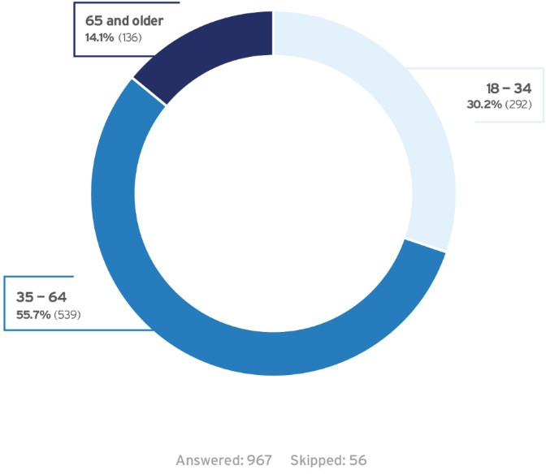Of the 967 respondents who shared their age range, over 55% were between ages 35 and 64,

approximately 30% were

between ages 18 and 34, and the smallest percentage of respondents, or 14%, were age 65 or older.

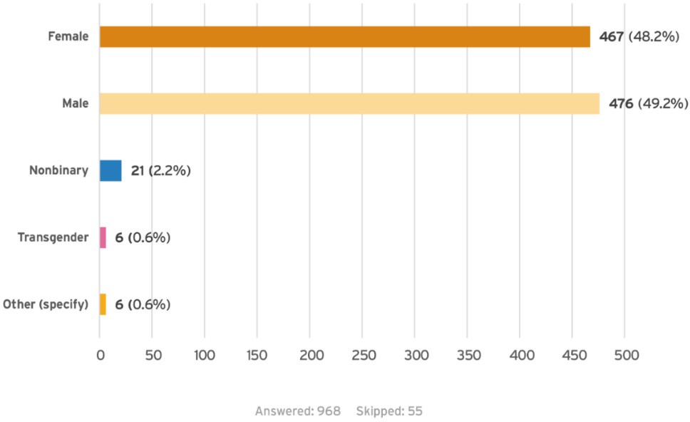**Gender**

Of the 968 respondents who answered this question, just over 48% identified as female and just over 49% identified as male. Approximately 2% of respondents identified as nonbinary and under 1% identified as transgender or selected “other.”

**Zip Code**

Home ZIP Code *[Note: Respondents were asked to provide their home ZIP code or to indicate if they are unhoused]*

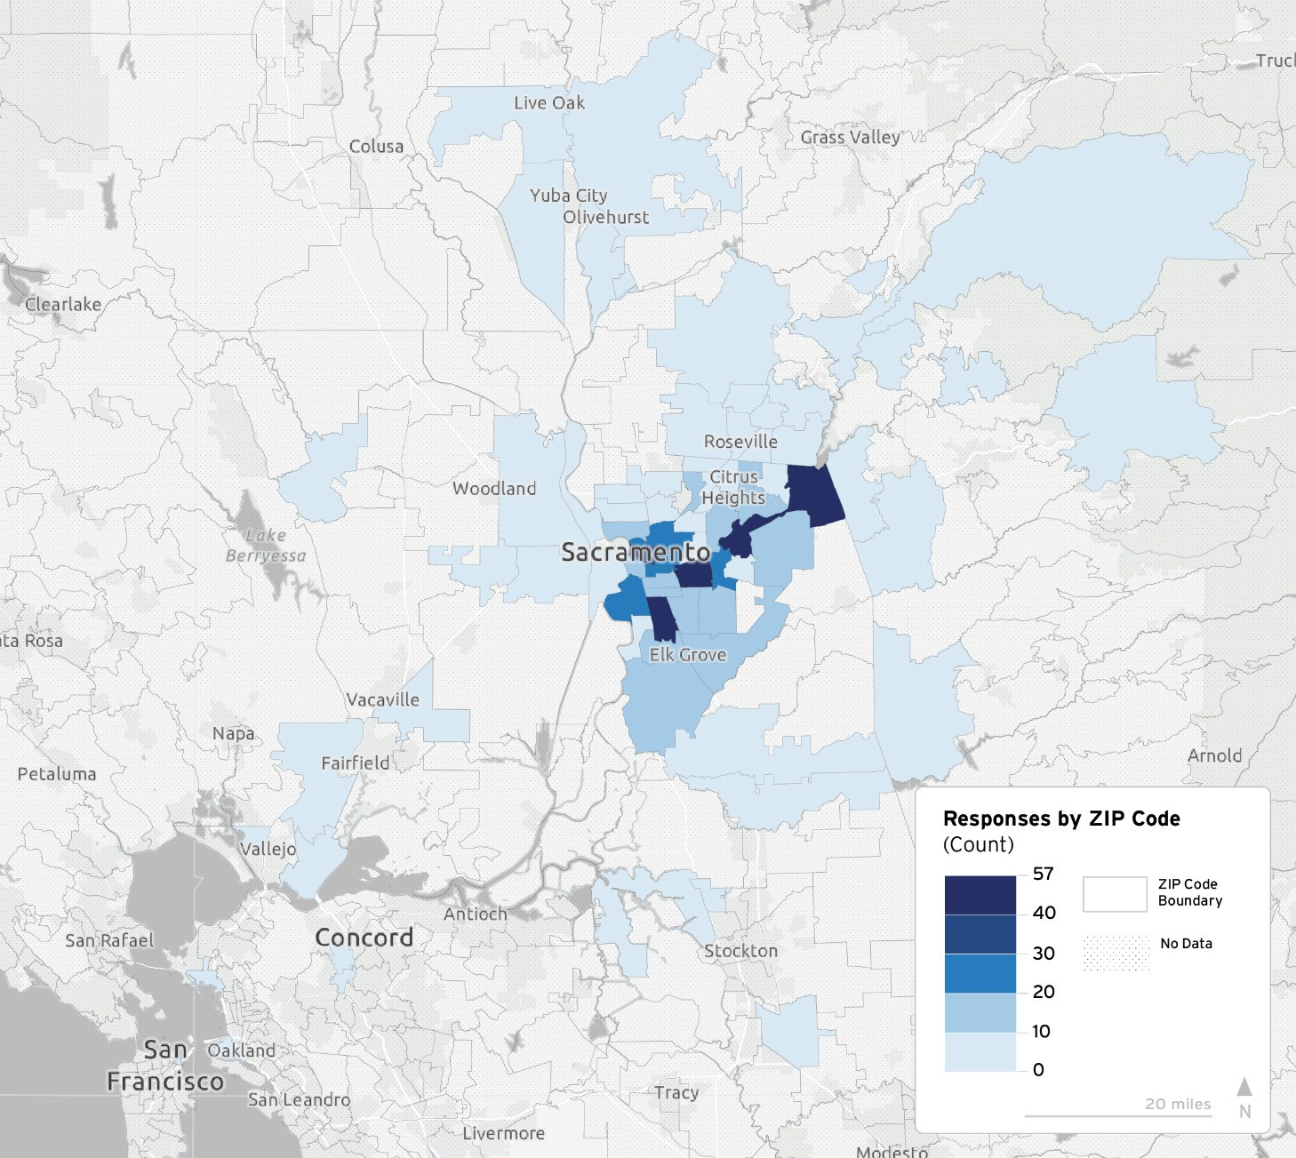

There were 936 responses to this question. The map above displays the frequency of ZIP codes submitted by 889 respondents who provided a ZIP code. Of the total responses to this question, 47 (5%) of the respondents indicated they were unhoused. The map highlights areas within Sacramento County that have the highest concentration of submitted ZIP codes. Additionally, there were seven ZIP codes submitted from outside the Northern California region.

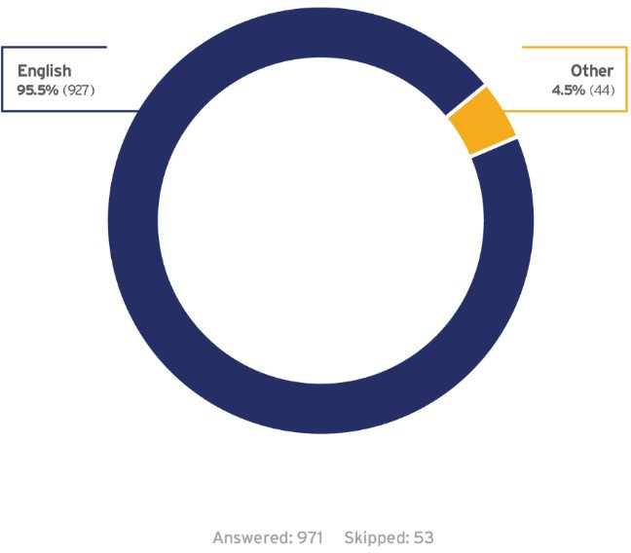**Primary Language**

Of the 971 respondents who answered the question, over 95% indicated that English was their primary language while approximately 4% indicated that their primary language was not English, as detailed in the figure below. Spanish was the most common non- English primary language.

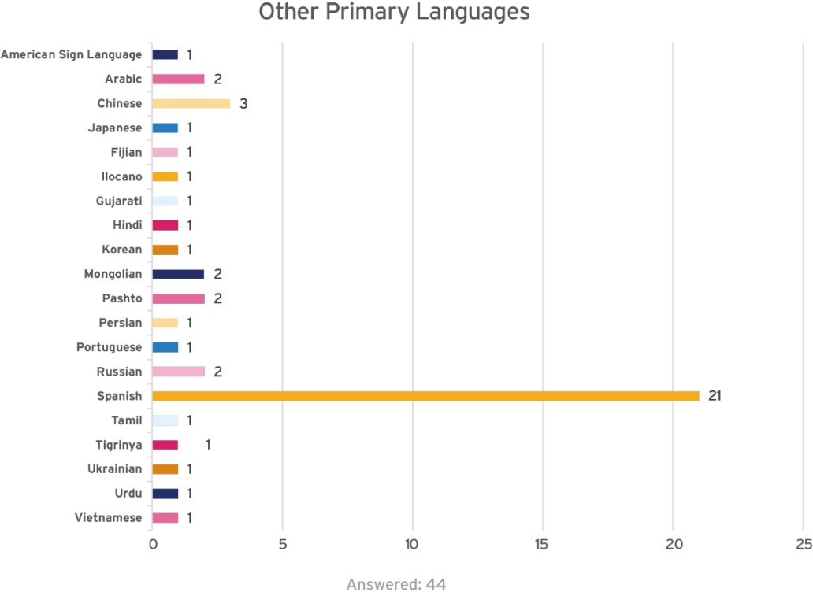

 19 people responded to the questionnaire using the Spanish questionnaire, 1 person responded to the questionnaire using the Russian questionnaire, and 42 people responded using an ADA accessible version of the questionnaire. The questionnaire was also available in Vietnamese, but no responses were received in Vietnamese.

**Race or Ethnic Identification**

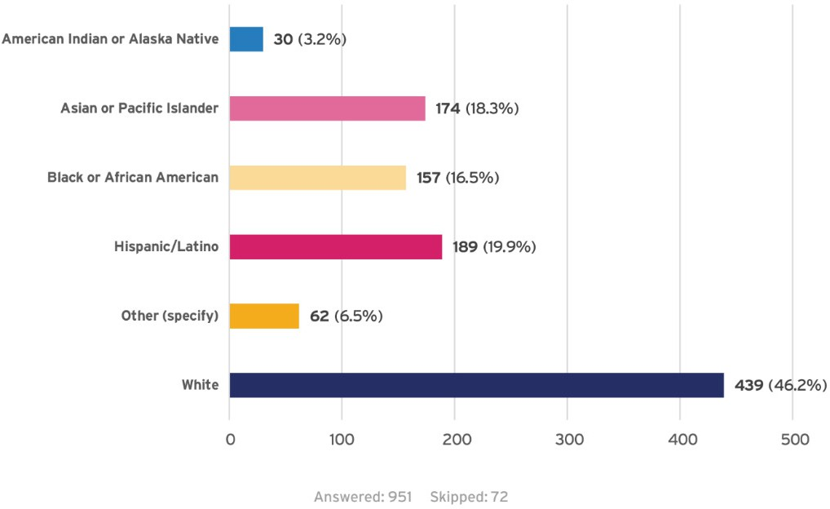**Disabilities**

Of the 951 respondents who answered the question, just over 3% identified as American Indian or Alaska Native, approximately 18% identified as Asian or Pacific Islander, approximately 17% identified as Black or African American, nearly 20% identified as Hispanic/Latino, over 6% specified “other,” and just over 46% identified as White.

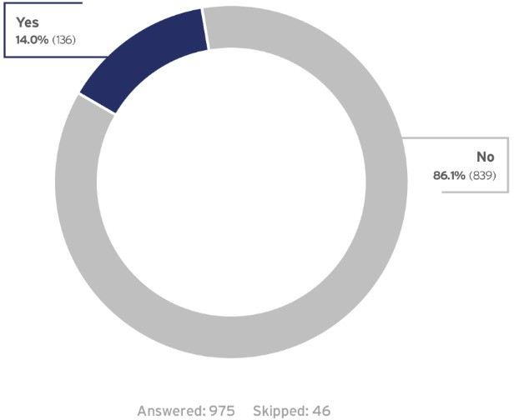Of the 975 respondents who answered this question, just over 86% indicated they do not have disabilities that impact their experience using SacRT services, while 14% of respondents indicated that they do have a disability impacting their experience with SacRT services.

**Annual Household Income**

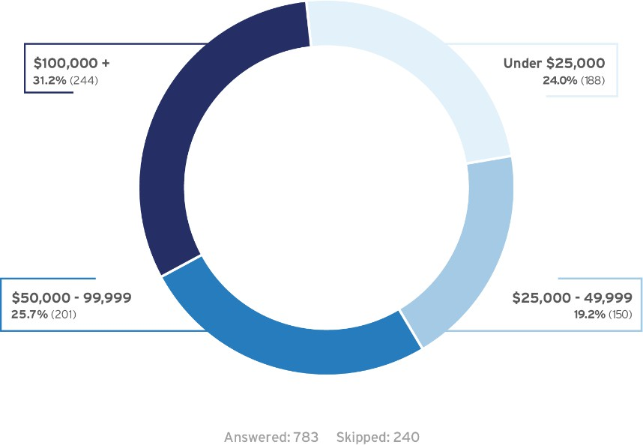

**Religion**

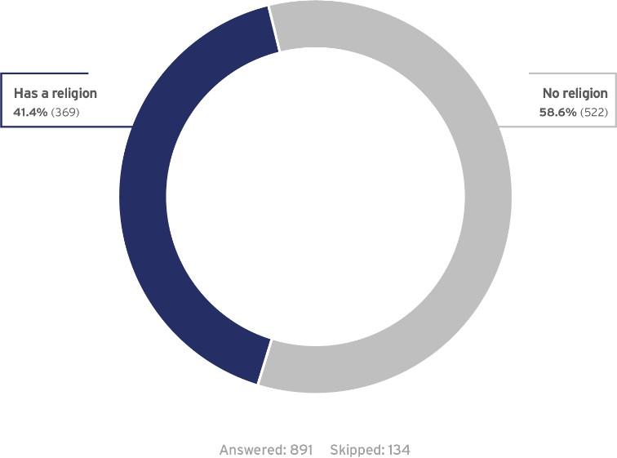

**LGBTQIA+**

Of the 783 respondents that answered the question, approximately 43% indicated an annual household income of below $50,000. Approximately one in four respondents indicated an annual household income of

$50,000 to $99,999. Lastly, approximately 31% of respondents indicated an annual household income of $100,000 or greater.

Of the 891 respondents who answered the question, approximately 41% indicated that they are affiliated with a religion, while the remaining 59% stated that are not.

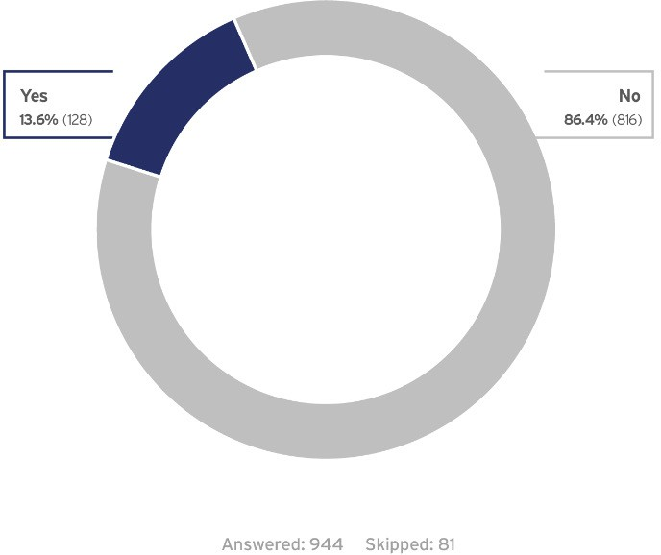Of the 944 respondents who answered the question, approximately 14% indicated that they identified with the Lesbian, Gay, Bisexual, Transgender, Queer, Intersex, Asexual Plus (LGBTQIA+) community.